WEST VALLEY-MISSION COMMUNITY COLLEGE DISTRICT
REQUEST FOR QUALIFICATIONS AND PROPOSALS (“RFP”)
DISTRICT-WIDE HVAC MAINTENANCE & REPAIR SERVICES
RFP # 6-1314

West Valley-Mission Community College District (“District”) requests that qualified firms with the minimum requisite 5 years’ experience (“Respondents”) to complete routine/scheduled maintenance and repairs to Heating, Ventilating and Air-Conditioning (“HVAC”) equipment submit responses to this RFP.

- The RFP.
  - Purpose of RFP. This RFP is a part of the process for the District’s selection and retention of a HVAC maintenance/repair services firm to provide routine scheduled maintenance and “on-call” “as-needed” repair services for District HVAC equipment. Scheduled/routine maintenance is referred to herein as “Maintenance” and “as needed” repair services are referred to herein as “Repairs.” Timely submitted RFP Responses will be evaluated to ascertain the Respondents’ respective qualifications, based on the criteria established in this RFP. Following the determination of which Respondents meet or exceed the qualifications standards set forth in this RFP, the District will evaluate pricing proposals submitted by the qualified firms.

  - Obtaining RFP From District. Notwithstanding public advertisement of the availability of this RFP, the District will only consider RFP Responses submitted by a Respondent who has obtained the RFP from the District by contacting the Ann Matthiessen, General Services, 14000 Fruitvale Avenue, Saratoga, CA 95070, ann.matthiessen@wvm.edu. A RFP Response submitted by a Respondent who has not obtained the RFP from the District pursuant to the foregoing will be deemed non-responsive and rejected.

  - District Modifications to RFP. The District expressly reserves the right to modify any portion of this RFP prior to the latest date/time for submission of RFP Responses, including without limitation, the cancellation of this RFP. Modifications, if any, made by the District to the RFP will be in writing; potential Respondents who have obtained this RFP from the District prior to any such modifications will be issued modifications to the RFP by written addenda.

  - No Oral Clarifications/Modifications. The District will not provide any oral clarifications or modifications to the RFP or the requirements hereof; no employee, officer, agent or representative of the District is authorized to provide oral clarifications or modifications to the RFP. No Respondent shall rely on any oral clarification or modification to the RFP.

  - Errors/Discrepancies/Clarifications to RFP. If a Respondent: (i) encounters errors or discrepancies in this RFP or portions hereof; or (ii) seeks clarification of any portion of the RFP, the Respondent shall immediately notify Ann Matthiessen, General Services, via email: ann.matthiessen@wvm.edu. Responses of the District to the notice of any errors or discrepancies herein, or a clarification will be in writing; if in the sole judgment of the District, any clarification response affects the RFP or other Respondents, the District will issue the clarification response by a written addendum distributed to all potential Respondents who have theretofore obtained this RFP from the District. All requests for clarification of this RFP must be submitted and actually received by Ann Matthiessen no later than 2:00 P.M., May 1, 2014. The District will not respond to clarification requests submitted thereafter.

  - Mandatory Pre-Bid Meeting. The District will conduct a Mandatory Pre-bid Meeting on Wednesday, April 16, 2014, beginning 2:00 PM. Respondents are to meet at the West Valley Campus, Facilities Building, 14000 Fruitvale Avenue, Saratoga, California 95070-5678 for the Pre-Bid Meeting. A RFP Response submitted by any Respondent whose representative(s) did not attend the Mandatory Pre-bid Meeting, in its entirety, will be rejected by the District as being non-responsive. No potential Respondents will be allowed in the Pre-Bid Meeting after 2:10 PM.

  - Prevailing Wage Rates. Pursuant to California Labor Code §1773, the Director of the Department of Industrial Relations of the State of California has determined the generally prevailing rates of wages in the locality in which the Work is to be performed. Copies of these determinations, entitled “PREVAILING WAGE SCALE” are available for review on the internet at http://www.dir.ca.gov/dlsr/statistics_research.html. The Respondent awarded the Contract for the Work shall post a copy of all applicable prevailing wage rates for the Work at conspicuous locations at the Site of the Work. The Respondent and all Subcontractors performing any portion of the Work shall pay not less than the applicable prevailing wage rate for the classification of labor provide by their respective workers in prosecution and execution of the Work.

  - Public Records. Except for materials deemed Trade Secrets (as defined in California Civil Code §3426.1) and materials specifically marked “Confidential” or “Proprietary,” all materials submitted in response to this RFP are deemed property of the District and public records upon submission to the District. The foregoing notwithstanding, the District may reject for non-responsiveness the RFP Response of a Respondent who indiscriminately notes that its RFP Response or portions thereof are “Trade Secret” “Confidential” or “Proprietary” and exempt from disclosure as a public record. The District is not liable or responsible for the disclosure of RFP Responses, or portions thereof, deemed to be public records, including those exempt from disclosure if disclosure is by law, by an order of Court, or which occurs through inadvertence, mistake or negligence on the part of the District or its agents or representatives. If the District is required to defend or otherwise respond to any action or proceeding wherein request is made for the disclosure of the contents of any portion of a RFP Response deemed exempt from disclosure hereunder, by submitting a response to this RFP, each Respondent agrees to defend, indemnify and hold harmless the District in any action or proceeding from and against any liability, including without limitation attorneys’ fees arising therefrom. The party submitting materials sought by any other party shall be solely responsible for the cost and defense in any action or proceeding seeking to compel disclosure of such materials; the District’s sole involvement in any such action shall be that of a stakeholder, retaining the requested materials until otherwise ordered by a court of competent jurisdiction.

  - Contractors’ License. The District will only consider RFP Responses submitted by Respondents who are currently licensed in good standing by the California Contractors’ State License Board as a C-20 (Warm-Air Heating, Ventilating and Air-Conditioning) Contractor. The RFP Response of a Respondent who is not so licensed will be rejected for non-responsiveness.

  - Minimum Experience Requirement. To qualify, Respondents must have five (5) years’ experience servicing HVAC Maintenance Agreements for Commercial facilities and/or Educational Facilities of over 500,000 square feet.

  - Pricing Proposals. The pricing proposed by each Respondent submitting a RFP Response for Maintenance and Repairs shall remain firm for one hundred twenty (120) days after the date of the District’s opening of RFP Responses. If the District’s Board of Trustees has not taken action to award the HVAC Agreement prior to expiration of the one hundred twenty (120) days that pricing proposals are to remain firm, the District may, in the sole and exclusive discretion request that Respondents timely submitting a responsive RFP Response hold their respective pricing proposals firm for an additional maximum one hundred twenty (120) day period. In such event, only those Respondents who affirmatively and unequivocally committed in writing to holding firm their respective pricing proposals will be further considered for award of the HVAC Agreement; the RFP Response of Respondents who do not so affirmatively and unequivocally commit in writing to hold firm pricing proposals will be thereupon be deemed non-responsive and not further considered.

  - Best and Final Offers. The District reserves the right, after the opening of RFP Responses to request all or some of the Respondents to submit “Best and Final Offers” (“BAFO”). The RFP Response of a Respondent who has been requested by the District to submit a BAFO, but fails or refuses submit the BAFO in accordance with the District’s request will be rejected for non-responsiveness.

  - District Negotiations. The District reserves the right (whether or not the District elects to engage in the BAFO process) negotiations with one or more Respondents regarding pricing, contract terms or other aspects of the requirements of the HVAC Agreement.

  - Evaluation Criteria. RFP Responses will be evaluated in accordance with the following evaluation criteria and the relative weighting of evaluation criteria.

Criteria | Weight
Proposed Maintenance Pricing | 35%
Proposed Repair Pricing | 15%
Respondent Technical Expertise | 20%
Prior HVAC Maintenance/Repair Experience | 20%
Acceptance of HVAC Agreement Without Proposed Modifications | 10%

  - Attachments. The following Attachments are incorporated into this RFP and form a part of this RFP:

- HVAC Agreement
- Qualifications Statement
- HVAC Pricing Proposal
- Repair Services/Additional Services Pricing Proposal.

  - Notice of Intent to Award HVAC Agreement. At least five (5) days prior to the date of the District’s Board of Trustees meeting to consider award of the HVAC Agreement, the District will issue a Notice of Intent to Award the HVAC Agreement, identifying the Respondent to whom the District intends to award the HVAC Agreement and the date/time/place of the District’s Board of Trustees meeting at which award of the HVAC Agreement will be considered.

  - Bid Protest. Any Respondent submitting a RFP Response to the District may file a protest of the District’s intent to award the HVAC Agreement provided that each and all of the following are complied with: (i) the bid protest is in writing; (ii) he bid protest is filed and received by the District’s Vice Chancellor, Administrative Services not more than three (3) calendar days following the date of issuance of the District’s Notice of Intent to Award the Contract; and (iii) the written bid protest sets forth, in detail, all grounds for the bid protest, including without limitation all facts, supporting documentation, legal authorities and argument in support of the grounds for the bid protest; any matters not set forth in the written bid protest shall be deemed waived. All factual contentions must be supported by competent, admissible and creditable evidence. If the District does not issue a Notice of Intent to Award the Contract at least five (5) calendar days prior to the date of the Board of Trustees meeting to consider award of the Contract, the latest date/time for timely submission of bid protests shall be 12:00 P.M. of the second (2nd) business day preceding the date of the Board of Trustees meeting to consider award of the HVAC Agreement. In such event, a bid protest submitted thereafter all be deemed rejected without further action of the District. Any bid protest not conforming with the foregoing shall be rejected by the District as invalid. Provided that a bid protest is filed in strict conformity with the foregoing, the District’s Vice Chancellor, Administrative Services or such individual(s) as may be designated by him/her, shall review and evaluate the basis of the bid protest. The District’s Vice Chancellor, Administrative Services or other individual designated by him/her shall provide the Respondent submitting the bid protest with a written statement concurring with or denying the bid protest. Action of the District’s Vice Chancellor, Administrative Services is final and not subject to appeal to any other employee or officer of the District or the District’s Board of Trustees. The rendition of a written statement by the District’s Vice Chancellor, Administrative Services (or his/her designee) addressing disposition of the bid protest is an express condition precedent to the institution of any legal or equitable proceedings relative to the bidding process, the District’s intent to award the HVAC Maintenance Agreement, the District’s disposition of any bid protest or the District’s decision to reject all RFP Responses. In the event that any such legal or equitable proceedings are instituted and the District is named as a party thereto, the prevailing party(ies) shall recover from the other party(ies), as costs, all attorneys’ fees and costs incurred in connection with any such proceeding, including any appeal arising therefrom.

- The District and the HVAC Equipment.
  - The District and the District’s Campuses.
The District is part of California’s public community college system of 109 colleges in 72 districts across the state, which serves more than 2.5 million students and represents the largest system of higher education in the world. Community colleges are political subdivisions authorized by the Constitution of the State of California. A seven-member Board of Trustees governs the District. The voters of the communities served by the District elect Board members to office. The Board of Trustees is responsible for the overall direction and control of the District so that it best meets the needs of the community it serves. The West Valley-Mission Community College District has a population of approximately 350,000 people residing within its boundaries. Specifically, the District serves the town of Los Gatos and all, or portions of, the cities of Campbell, Monte Sereno, San Jose, Santa Clara, and Saratoga.

West Valley College is located on the west side of Silicon Valley, in the foothills of the Santa Cruz Mountains, 50 miles south of San Francisco. Continuing a nearly 40 year tradition, West Valley College offers 18 dynamic career programs, professional certificates, and degree programs with exceptional preparation for transfer to four-year colleges and universities. The West Valley College campus consists of 143 acres with a student population of 12,233 (Fall 2009). There are 176 full time faculty members and 303 associate faculty members. West Valley College awards AA degrees in 58 different programs and offers 91 certificate programs. The District’s administrative offices are also situated on the West Valley College campus.

Mission College is located within the City of Santa Clara in the heart of Silicon Valley. Offering more than 70 academic, vocational, basic skills, and enrichment programs, Mission College serves students seeking to earn an AA degree, certificate of proficiency or to prepare for transfer to a four year university.

  - District-Wide HVAC Equipment. The HVAC Equipment subject to this RFP is described below. The extent of Maintenance for each piece of Equipment shall be in accordance with manufacturer’s recommendations. If a piece of Equipment is not subject to specific manufacturer’s recommendations for Maintenance, the successful Respondent will be required to provide Maintenance for such Equipment in accordance with industry “best practices” standards.

- HVAC Services Contract.
Incorporated as Attachment 1 to this RFP is a form of HVAC Services Agreement (“HVAC Agreement”) which the District anticipates executing with the successful Respondent selected through this RFP. All Respondents must thoroughly review the HVAC Agreement and indicate in Tab 4 of the RFP Response acceptance of the entirety of the HVAC Agreement or the portions of the HVAC Agreement for which modifications are proposed by a Respondent. If a Respondent proposes modifications to the HVAC Agreement, the District will not consider any such proposed modifications unless the Respondent sets forth in its RFP Response the entirety of the text of the proposed modification. If a Respondent does not identify proposed modifications to the HVAC Agreement in the Respondent’s RFP Response and such Respondent is awarded the HVAC Agreement, the Respondent is deemed to have accepted the entirety of the HVAC Agreement and shall execute the HVAC Agreement in the form attached hereto.

- RFP Response.
  - RFP Activities; Timeline. The following is a description of the principal activities to be completed under this RFP and the date for anticipated completion of each activity. The following notwithstanding, the District expressly reserves the right to amend the extent, nature or scope of RFP activities and/or the time for completing RFP activities.

ACTIVITY | DATE
Mandatory Pre-bid Meeting | April 16, 2014 @ 2:00 PM
Latest date/time for Respondents’ Submission of Clarifications Requests/RFP Questions | May 1, 2014 @ 2:00 p.m.
Respondents’ Submission of RFP Response | May 14, 2014 @ 2:00 p.m.
District Review of RFP Responses | May 15-22, 2014
Short List Candidates Interviews (at District discretion) | May 27-30, 2014
District Board of Trustees Action to Award HVAC Agreement | June 17, 2014

  - Submission of RFP Response.
    - Latest Date/Time for Submission of RFP Response. The latest date/time for submission of RFP Responses is 2:00 P.M., May 14, 2014. RFP Responses which are not actually received in the office of the District’s Director, General Services at or prior to the latest date/time for submission of RFP Responses will be rejected by the District for non-responsiveness. Respondents are solely responsible for the timely submission of RFP Responses. Respondents are encouraged to personally delivery RFP Responses directly to the office of the District’s Director, General Services or to retain a private courier/messenger service to personally deliver RFP Responses to the Office of the Director, General Services to ensure timely delivery to the proper location for submission of RFP Responses.

    - Location for Submission of RFP Response. RFP Responses shall be submitted to Director, General Services, West Valley College, 14000 Fruitvale Avenue, Saratoga, California 95070-5678.

    - RFP Response Costs. All costs and expenses incurred by a Respondent to prepare and submit a response to this RFP and all other related activities shall be borne solely and exclusively by the Respondent.

  - RFP Submission Format
    - RFP Response. All materials submitted in response to this RFP shall be on 8 ½” x 11” paper, preferably in portrait orientation. All submitted materials must be bound in either a three-ring binder or spiral bound notebook. Tabbed dividers should be used to identify and separate discrete sections of the RFP Response which correspond to the information requested in Paragraph 4.4 below.

    - Additional Materials. Respondents are not prohibited, but are discouraged, from submitting materials in addition to those specifically responding to the matters noted in Paragraph 4.4 below. If a Respondent elects to submit materials with its RFP Response which are in addition to the matters described in Paragraph 4.4 below, the Respondent shall separately bind all such additional materials separately from the RFP Response addressing the matters set forth in Paragraph 4.4 below.

  - Copies of RFP Response. Each Respondent shall submit an original and seven (7) copies of its RFP Response.
    - RFP Response Format/Contents. Each RFP Response must conform to the following described format and must include the content described below. Failure of a Respondent to submit its RFP Response in a format and with content conforming to the following requirements will be a basis for the District’s rejection of such RFP Response for non-responsiveness.

    - Cover Sheet. Identify the submittal as the Response to this RFP and an identification of the firm submitting the RFP Response along with the firm’s address, telephone/fax numbers and email addresses of the firm’s principal contacts in connection with this RFP or the RFP Response.

    - Letter of Interest. Include a brief letter expressing the interest of the Respondent in providing the Maintenance and Repair services contemplated by this RFP and the HVAC Agreement along with a brief statement of the qualifications of the Respondent to provide the Maintenance and Repair services described in the attached HVAC Agreement. Provide contact information, including the telephone number, fax number and email address for the personnel of the Respondent who will be receiving notices and other communications from the District regarding the RFP. The letter of interest should be bound with other materials responding to this RFP.

    - Table of Contents. Include a Table of Contents reflecting the Respondent’s responses to each of the items set forth below.

    - Tab 1; Statement of Qualifications. Complete the Statement of Qualifications incorporated into this RFP as Attachment 2.

    - Tab 2; Relevant Experience. Provide details of the Respondent’s skills, experience and expertise to provide the Maintenance and Repair services contemplated by this RFP and the HVAC Agreement. This portion of the RFP Response must contain three subparts: (i) general description of the Respondent’s capabilities as a firm to perform and complete Maintenance and Repair services; (ii) specific qualifications, experience and skills of the Respondent’s personnel proposed to provide Maintenance or Repair services, including without limitation, educational background, industry background, academic certifications and manufacturer certifications; and (iii) identify not more than five (5) and not fewer than two (2) current contracts or assignments for Maintenance and Repair services similar in scope to that contemplated by this RFP to which the Respondent is a party and primarily responsible for undertaking and completing such Maintenance and Repair services; contracts or assignments in this portion of Tab 2 should preferably be in connection with California public education institutions (K-12, community college, CSU or UC) or commercial facilities.

    - Tab 3; Comprehensive Service Plan. The O&M Provider shall provide all operations and preventative maintenance services for each piece of equipment identified in the Campus HVAC Equipment Schedules (and set forth in Exhibits A and B to the Agreement) in accordance with the manufacturer’s recommendations. Such services shall include, without limitation, all quarterly, semi-annually and annually required services, annual startup and shutdown plans for the cooling and heating systems, all requisite tests. Respondents shall submit, as part of their RFP Response, a proposed Comprehensive Service Plan detailing the requisite services and tasks included in Respondent’s RFP Response and proposed pricing. Once the O&M Provider and the District have agreed upon the Comprehensive Service Plan, it will be attached as Exhibit C to the Agreement, and no additional work shall be performed unless it is authorized in writing by the District’s Campus Facility Manager.

    - Tab 4; Insurance Certificates. Provide copies of Certificates of Insurance for the Respondent confirming the minimum coverage amounts for each policy of insurance as set forth below.

Required Insurance Policy Certificate | Minimum Coverage Amount
Workers Compensation | In accordance with law
Employers Liability | One Million Dollars ($1,000,000)
Comprehensive General Liability (including property damage and automobile liability) | Two Million Dollars ($1,000,000) per occurrence/Four Million Dollars ($2,000,000) in the aggregate

    - Tab 5; HVAC Agreement Comments. Included with this RFP is the HVAC Agreement. Respondents must thoroughly review the HVAC Agreement included herewith and must in their respective RFP responses identify any term or condition of the HVAC Agreement which the Respondent requests modification, by amendment to existing provisions, addition of additional provisions or deletion of existing provisions. Where any requested modification consists of amendments to existing provisions or additional provisions, the response to this RFP must set forth the text of the requested amendment or addition. Any Respondent whose RFP Response does not identify modifications to terms or conditions of the attached HVAC Agreement will be deemed to have agreed to all terms and conditions set forth therein; if awarded the HVAC Agreement, such Respondent must execute the HVAC Agreement in the form and content attached hereto subject only to elements of such Respondent’s RFP Response accepted by the District.

    - Tab 6; Proposed Pricing. Attachment 3 is a generic scope of work that applies to the majority of the manufacturers’ recommendations for their respective equipment types, but the actual scope may vary based on the O&M of the specific manufacturer. The District makes no representations as to the completeness or correctness of this generic scope of work. Respondent awarded the Contract will, however, be responsible not only for researching the manufacturers’ recommended maintenance requirements for each and every piece of HVAC Equipment identified on the HVAC Equipment List, attached as Exhibits A and B to the HVAC Agreement (“the HVAC Matrix”), but providing the requisite manufacturer-recommended maintenance subject to the Maintenance and Repair services under the HVAC Agreement. The HVAC Matrix identifies each piece of HVAC Equipment per building and per campus. Each Respondent’s Price Proposal must include a fixed price for Maintenance services for each piece of HVAC Equipment identified in the HVAC Matrix for each Campus Building. In addition to proposed annual pricing by Campus Building for Maintenance services to each piece of HVAC Equipment identified in the HVAC Matrix, each Respondent must also complete proposed pricing for Repair services on Attachment 4 to this RFP (Repair Services Pricing Proposal). Failure of a Respondent to proposed annual fixed priced costs for Maintenance services by Campus Building for every piece of HVAC Equipment identified in the HVAC Matrix and/or the failure to provide all pricing requested by the form of Repair Services Pricing Proposal will render the RFP Response of such Respondent to be non-responsive and rejected.

Enhanced Maintenance Pricing. PG&E’s Commercial HVAC Quality Maintenance Program utilizes the new HVAC industry standard, The American Society of Heating, Refrigeration and Air Conditioning Engineers (ASHRAE)/Air Conditioning Contractors for American (ACCA) Standard 180, which supports increased HVAC performance with enhanced planned maintenance. PG&E’s Commercial HVAC Quality Maintenance Program offers incentives for qualifying HVAC units that receive enhanced maintenance from participating HVAC Service Contractors to optimize the performance and longevity of the units. If Respondent is a participating HVAC Service Contractor in PG&E’s HVAC Quality Maintenance Program, please identify the Pricing for the Enhanced Maintenance in the last column of the Price Proposal on Attachment 4.

- Award of HVAC Agreement. The District’s Board of Trustees will have the exclusive authority to take action for the award of the HVAC Agreement.

[END OF SECTION]

ATTACHMENT 1

AGREEMENT

This Agreement is entered into this ____ day of_____________, 2014 by and between West Valley Mission Community College District ("District") and _________________ ("O&M Provider") who are collectively referred to herein as "the Parties." This Agreement is entered into with reference to the following Recitals, all of which are incorporated herein by this reference.

RECITALS

WHEREAS, in or about, __________, 2014, the District issued a Request for Proposals ("the RFP") pursuant to which the District requested proposals to provide District-wide HVAC Operation and Maintenance Services for the District; the RFP is incorporated herein by this reference.

WHEREAS, on or about __________, 2014, the O&M Provider submitted a written response to the RFP (“the RFP Response”); by this reference, the RFP Response is incorporated herein.

WHEREAS, the O&M Provider is engaged in the business of providing operations and preventative maintenance service for institutional and commercial HVAC systems; the O&M Provider is duly qualified licensed and otherwise authorized to engage in the business of providing HVAC operations and preventative maintenance service.

WHEREAS, the District and the O&M Provider desire to establish the terms and conditions pursuant to which O&M Provider shall provide HVAC operations and preventative maintenance service at the District, as set forth in this Agreement.

NOW THEREFORE, for good and valuable consideration, the receipt and adequacy of which is acknowledged by the Parties and each of them, the Parties agree as follows:

- DISTRICT HVAC OPERATIONS AND PREVENTATIVE MAINTENANCE SERVICE. The O&M Provider shall provide HVAC operations and preventative maintenance service at the District as set forth herein.
  - District Objectives. The District’s objectives in securing the services of O&M Provider include, in no particular order: (1) improving operating efficiency of mechanical plant and HVAC equipment; (2) applying preventative maintenance procedures to reduce chances of premature equipment failures; (3) improving operating efficiency of all mechanical systems and reduce energy waste; (4) providing for periodic inspection of building systems to avoid emergency breakdown situations; and (5) providing maximum comfort for building occupants.
  - District-wide HVAC Equipment. This Agreement is intended to include all HVAC Equipment in all buildings located on the West Valley College Campus and the Mission College Campus and identified on each Campus’ respective HVAC Equipment Schedule, attached hereto as Exhibit A and B. Each exhibit sets forth an inventory of the HVAC Equipment for the West Valley Campus and Mission Campus, respectively, which is subject to this Agreement. The extent of maintenance for each piece of equipment shall be in accordance with the manufacturer’s recommendations. If a piece of equipment is not subject to specific manufacturer’s recommendations for maintenance, the O&M Provider shall provide maintenance for such equipment in accordance with industry “best practices” standards.

- GENERAL. All operations conducted by the O&M Provider pursuant to this Agreement shall comply with the following general requirements.
  - Compliance with Laws. The O&M Provider shall ensure that all operations of the O&M Provider under this Agreement shall comply with applicable laws, ordinances, rules and regulations (collectively "the Laws"), including without limitation, the Laws of the State of California, County of Santa Clara and the City of Saratoga.
  - Licenses, Permits, Governmental Authorizations. The O&M Provider now has and shall maintain, at its sole cost and expense, all licenses, permits, governmental authorizations and/or approvals required by any federal, state or local governmental or regulatory bodies necessary for its operations under this Agreement.
  - Standard of Care. The O&M Provider shall provide the Basic Services and any and all authorized additional Repair Services and/or Additional Services under this Agreement: (i) using their professional skill and judgment exercised by other reasonable prudent licensed HVAC Maintenance providers in the same locale who were contracted to perform similar services; and (ii) acting with due care and in accordance with the applicable standard(s) of care under California law providing similar services.
  - Compliance with District Policies. All operations of the O&M Provider under this Agreement shall comply with applicable District policies in effect at the time this Agreement is executed, modifications to existing policies occurring after the date of execution of this Agreement and policies enacted during the Term of this Agreement.
  - Maintenance of Books and Records. The O&M Provider shall maintain books and accounting records of expenses and revenue in connection with its operations under this Agreement. Books and accounting records shall be contemporaneously maintained in accordance with generally accepted accounting principles applied in a consistent manner. Books and accounting records, along with underlying source data, shall be available to the District for review, inspection or reproduction upon reasonable advance request at O&M Provider's principal place of business or at the District. Following conclusion of this Agreement, whether by expiration of the Term or termination, O&M Provider shall maintain its books and accounting records for five (5) years or such longer period required by applicable law, code, rule, or regulation, during which time such records shall be available to the District or as otherwise required by law, code, rule or regulation for inspection and reproduction.
  - Assignment of Agreement and/or License. O&M Provider shall not, without prior written authorization from the District, which may be withheld at the District’s sole discretion, sell, assign, transfer or otherwise convey this Agreement and/or the rights and obligations granted herein to any other person, entity or organization.

- BASIC SERVICES
  - General O&M Service Plan. The O&M Provider shall provide all operations and preventative maintenance services for each piece of equipment identified in the Campus HVAC Equipment Schedules (and set forth in Exhibits A and B hereto) in accordance with the manufacturer’s recommendations. Such services shall include, without limitation, all quarterly, semi-annually and annually required services, annual startup and shutdown plans for the cooling and heating systems, all requisite tests. A Comprehensive Service Plan detailing the requisite services and tasks for each piece of equipment is attached hereto as Exhibit C and incorporated herein by reference in its entirety. No additional work shall be performed unless it is authorized in writing by the District’s Campus Facility Manager. All service technicians servicing District facilities shall, at a minimum, be journeyman rated or equivalent. The District reserves its right to update and/or modify the District-wide HVAC Equipment Schedule (Exhibits A and B) to reflect equipment that has been added, replaced, permanently removed and/or placed in suspension for a period of thirty (30) days or longer.

  - Verification, Documenting, Tracking and Reporting Requirements. Within thirty days of the commencement of this Agreement, the O&M Provider shall verify that the District-wide HVAC Equipment Schedules (Exhibits A and B) accurately identify all HVAC equipment on the West Valley Campus and Mission Campus, respectively. The O&M Provider shall be solely responsible for and comply with the requisite documenting, tracking and reporting requirements.

    - Technician Check-in. The O&M Provider’s technicians shall report to the Campus Facilities Manager at each campus and sign a log when entering and leaving each District campus.
    - Handheld Electronic Recording Devices. If the O&M Provider uses handheld electronic recording devices to capture data and information from the equipment, the O&M Provider shall provide the District with a paper copy of the data captured [and/or enter the data captured onto the District’s onsite computer.]
    - Log Cards. The O&M Provider shall place log cards at each piece of equipment with space for noting the date of each service, any new parts there were installed during such service, the requisite measurements such as motor amps and volts, temperatures and pressures, and the initials of the technician performing the service.
    - Service Tickets. The O&M Provider shall prepare and submit two (2) copies of a forms-based service ticket, which shall include a complete task sheet listing the equipment serviced on any given date and explaining exactly what work was performed for each piece of equipment listed, whether the work performed was in response to a scheduled serve call or other repair, together with recommendations for improvements, repairs and replacement. One copy is to be delivered to the District’s Campus Facility Manager and the one copy shall remain with the O&M Provider.
    - Requisite Measurements. The O&M Provider shall record the requisite measurements for each piece of equipment being services including, without limitation, motor amps and volts, temperatures and pressures. The requisite measurements shall be recorded on the Log Cards placed at each piece of equipment and on the forms-based service ticket.
    - Safety Hazards. The O&M Provider shall report any safety hazards or possible environmental quality problems to the District’s Campus Facility Manager.
    - Hazardous Materials. The O&M Provider shall use and provide only environmentally safe products on the District’s equipment and District campuses. O&M Provider shall provide copies of Material Safety Data Sheets to District O&M prior to bringing to the site any chemical required for performing a service task. Unless the O&M Provider receives written approval from the District, any chemicals brought on the District campuses shall be removed by the O&M Provider, along with any waste associated with them. The O&M Provider shall dispose of any material considered to be “hazardous” under any federal, state, or local statute, regulation, rule ordinance in a lawful and environmentally safe manner and ensure that no hazardous chemicals are put into the District’s waste stream.
    - Test Results. The O&M Provider shall provide the District’s Facility Manager with a copy of any test results, such as oil analysis, water treatment analysis, or boiler combustion analysis.
    - Billing Records and Requirements. The O&M Provider shall implement stringent billing practices that include, without limitation:
      - The technician performing the service must sign the service invoice;
      - The technician must clearly and legibly describe each task performed on each piece of equipment, including labor time and replacement parts, if any;
      - Any electronically acquired data must be made available to the Director O&M as hard copy or on a site-based District computer;
      - All old parts must be presented to District’s Campus Facility Manager for inspection and, if instructed, disposed of by O&M Provider.
      - The building name and number, together with equipment Unit ID number, must be included on the service invoice;
      - The O&M Provider shall provide a separate bill for additional work performed at the time of regular preventative maintenance visit. The O&M Provider shall obtain prior approval for work if the cost exceeds Five Hundred Dollars ($500.00) per routine maintenance service call.
      - Bills must be received by the District within sixty (60) days of the date of performance of work. O&M Provider expressly waives it right to payment for any all work not billed within sixty (60) days of the date of performance.

  - Calibration Requirements.
    - Instrument Calibration. The O&M Provider’s test instruments shall have up-to-date and valid calibration documentation. This may be in the form of a certificate from the manufacturer, or other company or governmental agency performing the calibration. O&M Provider shall provide District with a copy of the instrument calibration documentation upon execution of this Agreement, and shall submit to the District’s Campus Facility Manager updated calibration documentation to the District every six (6) months.
    - Equipment Calibration. Periodic calibration checks are among the most important preventative maintenance tasks for ensuring that the equipment and systems are performing optimally. Any sensors or equipment calibrated by the O&M Provider shall have a calibration label identifying the O&M Provider, the name of the technician performing the calibration and the date of calibration.

  - Certifications and Safety Requirements.
    - CFC Certification. O&M Provider’s technicians shall be CFC Certified and shall have received training on venting, recovery, recycling, and replacement of chlorofluorocarbons (CFCs), hydrochlorofluorocarbons (HCFCs), and other refrigerants used in air conditioning and refrigerant systems, units, and shall appliances, and have taken and passed and EPA-approved test appropriate for the equipment that they service and/or dispose of.
    - Contractors’ Hazard Materials/Refrigerant Policy Agreement. The O&M Provider shall sign the O&M Provider’s Hazardous Materials/Refrigerant Policy Agreement, attached hereto as Attachment D and shall provide District with the Federal Certification numbers for all of its service technicians.
    - Tracking of Refrigerant. The O&M Provider shall track all HVAC refrigerants on the District campuses, including current inventory, equipment leaks, and leakage rates. Also, in the event of a refrigerant changeout, the O&M Provider shall issue a credit for the old refrigerant of at least 75% of the current wholesale market price.
    - Personal Protective Equipment. The O&M Provider shall provide all personal protective equipment such as harnesses, hardhats, safety glasses, and breach protection, and ensure that all technicians and service personnel are trained and qualified in their use.
    - Safety Meetings. The O&M Provider shall at the commencement of this Agreement and every six (6) months thereafter, submit to the District O&M, evidence, such as meeting minutes, that the O&M Provider has held regular safety meeting with its staff technicians.
    - Encountering of Hazardous Materials. In the event the O&M Provider encounters Hazardous Materials at the District’s campuses which have not been rendered harmless or for which there is no provision in the Agreement for containment, removal, abatement or handling of such Hazardous Materials, the O&M Provider shall immediately stop the Work in the affected area, but shall diligently proceed with the Work in all other unaffected areas. Upon encountering such Hazardous Materials, the O&M Provider shall immediately notify the District’s Campus Facility Manager, in writing, of such condition. The O&M Provider shall proceed with the Work in such affected area only after such Hazardous Materials have been rendered harmless, contained, removed or abated.
    - Prohibited Use of Hazardous Materials. The O&M Provider shall execute the Contractor’s Hazardous Materials/Refrigerant Policy Agreement, attached hereto as Exhibit D to the Agreement, (i) agreeing to use/provide only environmentally safe products while doing business with West Valley-Mission Community College District, in fulfillment of this contract and (ii) acknowledging that all of its service technicians have received training on venting, recovery, recycling, and replacement of chlorofluorocarbons (CFCs), hydrochlorofluorocarbons (HCFCs), and other refrigerants used in air conditioning and refrigerant systems, units, and small appliances, and have taken and passed an EPA-approved test appropriate for the equipment that they service and/or dispose of.

  - Building Keys. The O&M Provider and its technicians shall sign for any keys to the District buildings at the time of check-in for the regularly scheduled maintenance or service call. Neither the O&M Provider nor its technicians shall take building keys off premises or attempt to copy any such keys if the O&M Provider or its technician is given a master key and misplaces the master key, the O&M Provider shall bear sole liability for payment for rekeying the building or buildings.

  - Hours and Days of Operation. The O&M Provider shall maintain an appropriately sized and skilled workforce, including supervisory personnel, to perform the requisite HVAC operations and maintenance services during the District’s hours of operation forth hereinbelow.
    - Regular District Sessions. With the exception of District holiday days, the District hours of operation are from 7:30 A.M. to 5:00 P.M. Monday through Friday.
    - Summer Sessions. During the District’s Summer sessions, the District hours of operation are from 7:30 A.M. to 5:00 P.M. Monday through Friday.
    - Inter-Sessions. During the District’s inter-sessions, the District hours of operation are from 7:30 A.M. to 5:00 P.M. Monday through Friday.
    - Emergency Repairs. The O&M Provider shall also maintain an appropriately sized and skilled workforce, including supervisory personnel, to perform the requisite emergency repairs to the HVAC systems both during and after the District’s regular hours of operation.

  - Contract Administrator. The District will designate an employee of the District as the Contract Administrator with authority to act on behalf of the District under this Agreement. The Contract Administrator is Brigit Espinosa, Director, General Service; by written notice to the O&M Provider, the District may change the Contract Administrator.

  - Incentives and Rebates. Contractor shall work with and assist the District in connection with the District’s completion and submission of applications for energy efficiency/conservation incentives and rebates offered by PG&E and other public and private agencies.

- REPAIR/ADDITIONAL SERVICES
  - Authorization for Repair and/or Additional Services. The services described in Section 4 are not included in the scope of O&M Provider’s Basic Services. The O&M Provider shall perform Repair Services and/or Additional Services only upon the express written authorization of the District. O&M Provider shall not be compensated for any or all Repair Services and/or Additional Services not authorized, in writing, in advance by the District.

  - Time. The O&M Provider shall commence work on all emergency repairs within two (2) hours and in no event later than four (4) hours after receipt of the District’s notification of the state emergency.

  - Fees for Repairs and/or Additional Services. Authorized Repair Services and Additional Services, which are not part of the Basic Services, shall be compensated on a time and material basis in accordance with the Fee Schedule attached hereto as Exhibit E and incorporated by reference in its entirety.

  - Allowance for Authorized Minor Repairs.

    - Allowance Per Campus. The West-Valley Campus and Mission Campus shall each maintain an Allowance of Thirty Thousand Dollars ($30,000.00) per year per campus for the sole purpose of funding “Minor Repairs” authorized by the respective Campus Facilities Manager in advance of the repair. O&M Provider shall not be compensated for any or all Minor Repair services not authorized, in writing, in advance by the Campus Facilities Director.
    - “Minor Repair” Defined. For purposes of this Agreement only, a “Minor Repair” is defined as a repair to HVAC equipment that is necessary to ensure the continued operation of the equipment, discovered during the O&M Provider’s routine scheduled service, and can be completed in less than two (2) working days with a combined costs for labor and materials not to exceed Three Thousand Dollars ($3,000.00).
    - Authorization Process. When the O&M Provider identifies an issue with HVAC equipment that necessarily requires a Minor Repair to ensure the continued operation of the equipment, the O&M Provider shall contact the Campus Facilities Manager, either in person, by telephone or e-mail, and: (i) identify the HVAC equipment that requires the Minor Repair necessary to ensure the continued operation of the equipment; (ii) identify the potential risk of failure or malfunction of the equipment, if applicable, and/or other potential hazards; (iii) provide a detailed cost estimate for the Minor Repair, including all labor, materials, taxes, and allowable mark-up, if any; and (iv) identify the date and time period when the Minor Repair will be made. The O&M Provider shall not proceed with the Minor Repair unless and until he/she receives written authorization from the Campus Facilities Director, which may be transmitted via e-mail, fax or other writing.

  - Warranty. The O&M Provider shall provide a one (1) year parts and labor warranty for all Repair Services and Additional Services performed pursuant to this Agreement. If, within one year after the date of completion of such work, any of the work is found to be defective or not in accordance with the equipment manufacturer’s requirements, or otherwise contrary to the warranties contained in this Agreement, the O&M Provider shall commence all necessary corrective action not more than seven (7) days after receipt of a written notice from the District to do so, and to thereafter diligently complete the same. In the event that O&M Provider shall fail or refuse to commence correction of any such item within said seven (7) day period or to diligently prosecute such corrective actions to completion, the District may, without further notice to O&M Provider, cause such corrective Work to be performed and completed. In such event, O&M Provider shall be responsible for all costs in connection with such corrective work, including without limitation, general administrative overhead costs of the District in securing and overseeing such corrective work. Nothing contained herein shall be construed to establish a period of limitation with respect to any obligation of the O&M Provider under this Agreement. The obligations of the O&M Provider hereunder shall be in addition to, and not in lieu of, any other guarantees or warranties provided by any manufacturer of any item or equipment forming a part of, or incorporated into the work, or otherwise recognized, prescribed or imposed by the Laws. Neither the District’s acceptance, the making of payment, any provision in this Agreement, nor the use or occupancy of the work, in whole or in part, by District shall constitute acceptance of work not in accordance with this Agreement or the manufacturer’s requirement nor relieve the O&M Provider from liability with respect to any warranties or responsibility for faulty or defective work or materials, equipment and workmanship incorporated therein.

  - Cutting and Patching. The O&M Provider shall be responsible for cutting, fitting or patching required to complete the Work or to make the component parts thereof fit together properly. The O&M Provider shall not damage or endanger any portion of the Work, or the fully or partially completed construction of the District or separate O&M Providers by cutting, patching, excavation or other alteration. When modifying new Work or when installing Work adjacent to an existing structure/facility, the O&M Provider shall match, as closely as conditions of the site and materials will allow, the finishes, textures and colors of the existing structure/facility and refinish elements of the existing structure/facility. The O&M Provider shall not cut, patch or otherwise alter the construction by the District or separate O&M Provider without the prior written consent of the District or separate O&M Provider thereto, which consent shall not be unreasonably withheld. The O&M Provider shall not unreasonably withhold consent to the request of the District or separate O&M Provider to cut, patch or otherwise alter the Work.

- Wage Rates; Employment of Labor.
  - Determination of Prevailing Rates. Pursuant to the provisions of Division 2, Part 7, Chapter 1, Article 2 of the California Labor Code at §§1770 et seq., the District has obtained from the Director of the Department of Industrial Relations the general prevailing rate of per diem wages and the prevailing rate for holiday and overtime work in the locality in which the Work is to be performed. Holidays shall be as defined in the collective bargaining agreement applicable to each particular craft, classification or type of worker employed under the Contract. Per diem wages include employer payments for health and welfare, pensions, vacation, travel time and subsistence pay as provided in California Labor Code §1773.8, apprenticeship or other training programs authorized by California Labor Code §3093, and similar purposes when the term “per diem wages” is used herein. Holiday and overtime work, when permitted by law, shall be paid for at the rate of at least one and one-half (1½) times the above specified rate of per diem wages, unless otherwise specified. The O&M Provider shall post, at appropriate and conspicuous locations on the Site, a schedule showing all determined general prevailing wage rates.
  - Minor Repair Authorization Process. Upon discovering a necessary “Minor Repair”

  - Payment of Prevailing Rates. There shall be paid each worker of the O&M Provider, or any Subcontractor, of any tier, engaged in the Work, not less than the general prevailing wage rate, regardless of any contractual relationship which may be alleged to exist between the O&M Provider or any Subcontractor, of any tier, and such worker.

  - Prevailing Rate Penalty. The O&M Provider shall, as a penalty, forfeit not more than Fifty Dollars ($50.00) to the District for each calendar day or portion thereof, for each worker paid less than the prevailing rates for such work or craft in which such worker is employed for the Work by the O&M Provider or by any Subcontractor, of any tier, in connection with the Work. The amount of the penalty for failure to pay applicable prevailing wage rates shall be determined and assessed in accordance with the standards established pursuant to Labor Code §1775(a)(2). The amount of the penalty shall be determined based on consideration of both of the following: (i) whether the failure of the O&M Provider or Subcontractor to pay the correct rate of per diem wages was a good faith mistake and, if so, the error was promptly and voluntarily corrected when brought to the attention of the O&M Provider or Subcontractor; and (ii) whether the O&M Provider or Subcontractor has a prior record of failing to meet its prevailing wage obligations. The penalty may not be less than ten dollars ($10) for each calendar day, or portion thereof, for each worker paid less than the prevailing wage rate, unless the failure of the O&M Provider or Subcontractor to pay the correct rate of per diem wages was a good faith mistake and, if so, the error was promptly and voluntarily corrected when brought to the attention of the O&M Provider or subcontractor. The penalty may not be less than twenty dollars ($20) for each calendar day, or portion thereof, for each worker paid less than the prevailing wage rate, if the O&M Provider or Subcontractor has been assessed penalties within the previous three years for failing to meet its prevailing wage obligations on a separate contract, unless those penalties were subsequently withdrawn or overturned. The penalty may not be less than thirty dollars ($30) for each calendar day, or portion thereof, for each worker paid less than the prevailing wage rate, if the Labor Commissioner determines that the violation was willful, as defined in subdivision (c) of Section 1777.1. When the penalty amount due hereunder is collected from the O&M Provider or Subcontractor, any outstanding wage claim under Chapter 1 (commencing with Section 1720) of Part 7 of Division 2 against that O&M Provider or Subcontractor shall be satisfied before applying that amount to the penalty imposed on that O&M Provider or Subcontractor hereunder. The difference between prevailing wage rates and the amount paid to each worker each calendar day, or portion thereof, for which each worker paid less than the prevailing wage rate, shall be paid to each worker by the O&M Provider.

  - Payroll Records. Pursuant to California Labor Code §1776, the O&M Provider and each Subcontractor, of any tier, shall keep an accurate payroll record, showing the name, address, social security number, work classification, straight time and overtime hours worked each day and week, and the actual per diem wages paid to each person employed for the Work. The payroll records shall be certified and available for inspection at all reasonable hours at the principal office of the O&M Provider on the following basis: (i) a certified copy of an employee’s payroll record shall be made available for inspection or furnished to such employee or his/her authorized representative on request; (ii) a certified copy of all payroll records shall be made available for inspection or furnished upon request to the District, the Division of Labor Standards Enforcement and the Division of Apprenticeship Standards of the Department of Industrial Relations; (iii) a certified copy of payroll records shall be made available upon request to the public for inspection or copies thereof made; provided, however, that a request by the public shall be made through either the District, the Division of Apprenticeship Standards, or the Division of Labor Standards Enforcement. If the requested payroll records have not been provided, the requesting party shall, prior to being provided the records, reimburse the cost of preparation by the O&M Provider, Subcontractors and the entity through which the request was made; the public shall not be given access to such records at the principal office of the O&M Provider; (iv) the O&M Provider shall file a certified copy of the payroll records with the entity that requested such records within ten (10) days after receipt of a written request; (v) any copy of records made available for inspection as copies and furnished upon request to the public or any public agency by the District, the Division of Apprenticeship Standards or the Division of Labor Standards Enforcement shall be marked or obliterated in such a manner as to prevent disclosure of an individual’s name, address and social security number. The name and address of the O&M Provider or any Subcontractor, of any tier, performing a part of the Work shall not be marked or obliterated. The O&M Provider shall inform the District of the location of payroll records, including the street address, city and county and shall, within five (5) working days, provide a notice of a change or location and address. In the event of noncompliance with the requirements of this Article, the O&M Provider shall have ten (10) days in which to comply, subsequent to receipt of written notice specifying in what respects the O&M Provider must comply herewith. Should noncompliance still be evident after such 10-day period, the O&M Provider shall, as a penalty to the District, forfeit Twenty-Five Dollars ($25.00) for each calendar day, or portion thereof, for each worker, until strict compliance is effectuated. Upon the request of the Division of Apprenticeship Standards or the Division of Labor Standards Enforcement, such penalties shall be withheld from any portion of the Contract Price then or thereafter due the O&M Provider. The O&M Provider is solely responsible for compliance with the foregoing provisions.

- Hours of Work.

  - Limits on Hours of Work. Pursuant to California Labor Code §1810, eight (8) hours of labor shall constitute a legal day’s work. Pursuant to California Labor Code §1811, the time of service of any worker employed at any time by the O&M Provider or by a Subcontractor, of any tier, upon the Work or upon any part of the Work, is limited and restricted to eight (8) hours during any one calendar day and forty (40) hours during any one calendar week, except as hereafter provided. Notwithstanding the foregoing provisions, Work performed by employees of O&M Provider or any Subcontractor, of any tier, in excess of eight (8) hours per day and forty (40) hours during any one week, shall be permitted upon compensation for all hours worked in excess of eight (8) hours per day at not less than one and one-half (1½) times the basic rate of pay.

  - Penalty for Excess Hours. The O&M Provider shall pay to the District a penalty of Twenty-five Dollars ($25.00) for each worker employed on the Work by the O&M Provider or any Subcontractor, of any tier, for each calendar day during which such worker is required or permitted to work more than eight (8) hours in any calendar day and forty (40) hours in any one calendar week, in violation of the provisions of the California Labor Code, unless compensation to the worker so employed by the O&M Provider is not less than one and one-half (1½) times the basic rate of pay for all hours worked in excess of eight (8) hours per day.

  - Contractor Responsibility. Any Work performed by workers necessary to be performed after regular working hours or on Saturdays, Sundays or other holidays shall be performed without adjustment to the Contract Price or any other additional expense to the District. The O&M Provider shall be responsible for costs incurred by the District which arise out of Work performed by the O&M Provider at times other than regular working hours and regular working days. Upon determination of such costs, the District may deduct such costs from the Contract Price then or thereafter due the O&M Provider.

- INSURANCE; INDEMNITY
  - O&M Provider Insurance. At all times during the Term of this Agreement, the O&M Provider shall obtain and maintain the insurance coverages noted herein; each required policy of insurance shall be in the minimum coverage amount noted herein.
    - Workers Compensation Insurance; Employer's Liability Insurance. The O&M Provider shall obtain Workers Compensation Insurance covering all employees of the O&M Provider engaged in operations under this Agreement. The Workers Compensation Insurance shall cover claims under workers' compensation, disability benefits and other similar employee benefit laws applicable to the O&M Provider's operations under this Agreement. The Employer's Liability Insurance shall cover bodily injury or death by accident or disease to any employee which arises out of the employee's employment by the O&M Provider. The Employer's Liability Insurance may be obtained as a separate policy of insurance or as additional coverage under the Workers Compensation Insurance policy. The minimum coverage amount under the Workers Compensation Insurance shall be in accordance with applicable law. The minimum coverage amount under the Employers Liability Insurance shall be One Million Dollars ($1,000,000).
    - Commercial General Liability Insurance. The Commercial General Liability Insurance obtained by the O&M Provider shall cover the types of claims set forth below which may arise out of or result from the operations of the O&M Provider under this Agreement. The Commercial General Liability Insurance shall cover: (a) claims for damages for bodily injury, sickness, disease or death of persons other than the O&M Provider's employees; (b) claims for damages due to injury or death of persons or damage to property, including the loss of use thereof; (c) claims for damages arising out of bodily injury or death of persons or damage to property arising out of O&M Provider’s ownership, maintenance or use of motor vehicles; (d) contractual liability applicable to the obligations under this Agreement; and (e) completed operations. The Commercial General Liability Insurance policy shall name the District including, without limitation, District officers, directors, employees, representatives, the District’s Board of Trustees and individual members of the Board of Trustees, as additional named insureds thereunder. The minimum coverage amount under the Commercial General Liability Insurance shall be One Million Dollars ($1,000,000) with Two Million Dollars ($2,000,000) aggregate.
    - Certificates of Insurance; Policy Requirements. Prior to the commencement of the Term of this Agreement, the O&M Provider shall deliver to the Contract Administrator Certificates of Insurance evidencing each of the insurance coverages required to be obtained and maintained by the O&M Provider. Each policy of insurance obtained by the O&M Provider hereunder shall provide, by endorsement or otherwise, that the policy of insurance will not be permitted to lapse or expire, or to be materially modified without at least thirty (30) days advance written notice to the District. All insurance shall be placed with California admitted insurers with a current A.M. Best’s rating of no than A:VII, unless approved by the District.
    - Deductibles; Premiums. The O&M Provider is solely responsible for the full and timely payment of premiums for policies of insurance the O&M Provider is required to obtain and maintain under this Agreement. In the event of a loss under a policy of insurance obtained and maintained by the O&M Provider hereunder, the O&M Provider shall be solely responsible for payment of the deductible, if any, associated with such loss. Any and all deductibles in excess of $2,000 must be approved by the District.
    - District Rights. If the O&M Provider fails or refuses to obtain and maintain any policy of insurance required hereunder, the District may, but is not obligated to, obtain such policy of insurance on behalf of the O&M Provider. If the District obtains a policy of insurance on behalf of the O&M Provider pursuant to the foregoing, the O&M Provider shall be responsible for payment of all premiums associated with such policy of insurance and an administrative fee equal to twenty-five percent (25%) of the premium costs.

  - District Insurance. During the Term of this Agreement, the District will maintain insurance against the perils, losses and claims described herein, provided that the District may, in its discretion, elect to self-insure, obtain commercially available insurance policy(ies) or obtain insurance coverages through one or more Joint Powers Authorities.
    - General Liability Insurance. The District will obtain General Liability Insurance covering the risks of death or bodily injury to persons and damage to property.
    - Property Casualty Insurance. The District will obtain Property Casualty Insurance which will include coverage for the risks of loss, damage or destruction to the District’s buildings and/or campuses. The foregoing notwithstanding, the District's Property Casualty Insurance will not provide coverage for the risk of loss, damage or destruction of items of personal property situated in, on or about the District campuses owned by the O&M Provider.

  - Waiver of Subrogation. The District and the O&M Provider each waive all rights of recovery against the other or against the Trustees, directors, partners, officers, employees, agents or representatives, as applicable, of the District and the O&M Provider, arising out of a loss or damaged which is insured under a policy of property casualty insurance in effect at the time of such loss or damage. The foregoing waiver shall be required of the insurers of the District and the O&M Provider to the extent that there are no additional premium costs for such waiver of subrogation.

  - O&M Provider Indemnification. To the fullest extent permitted by law, the O&M Provider shall indemnify, defend and hold harmless the District and, as applicable, its employees, officers, directors, Board of Trustees, individual members of the Board of Trustees, agents and representatives (“the Indemnified Parties”) from any and all claims, demands, losses, responsibilities or liabilities for: (i) injury or death of the O&M Provider's employees arising out of this Agreement; (ii) injury or death of persons or damage to property, or (iii) other costs or charges, directly or indirectly arising out of or attributable, in whole or in part, to the negligent or willful acts, omissions, errors and/or other conduct of the O&M Provider and its employees, agents and representatives. The foregoing shall include, without limitation, attorneys fees and costs incurred by the Indemnified Parties and shall survive the termination of this Agreement until any such claim, demand, loss, responsibility or liability covered by the provisions hereof is barred by the applicable Statute of Limitations.

- CONTRACT PRICE
  - Contract Price. The District shall pay the O&M Provider as full consideration for the O&M Provider’s full, complete and faithful performance of the O&M Provider’s obligations under this Agreement, subject to adjustments of the Contract Price for authorized Repair Services in accordance with this Agreement, the Contract Price of ______________________________________________Dollars ($_____________). The Contract Price is based upon the O&M Provider’s Response to the District’s Request for Proposals for District-wide HVAC Maintenance and Repair Services, RFP # 6-1314.

  - Payment of Contract Price. Payment of the Contract Price for Basic Services shall be paid in sixty (60) equal installments, with payment of each installment due within thirty days after District’s receipt of O&M Provider’s undisputed Invoice. Within thirty (30) days of receipt of O&M Provider’s billing invoices, District will make payment to O&M Provider of undisputed amounts of the Contract Price due for Basic Services and authorized Repair Services and/or Additional Services. Notwithstanding any provision of this Agreement to the contrary, if the District shall, in good faith, dispute the amount due O&M Provider under any billing invoice rendered by O&M Provider under this Agreement, the District may withhold from payment to the O&M Provider an amount to exceed one hundred and fifty percent (150%) of the disputed amount.

  - Expenses Included in Contract Price. The Contract Price includes the O&M Provider’s fee, technician fees, personnel expenses of the O&M Provider, including of all benefits and burdens, travel for the personnel of the O&M Provider to and from their respective offices and the District campuses, as well as travel within the counties of Santa Clara, Santa Cruz, San Benito, Contra Costa, San Francisco and Alameda, insurance and all other administrative or overhead costs associated with or arising out of performance of the Basic Services designated in this Agreement.

  - Taxes. In addition to the Contract Price, the District shall pay all sales, consumer, use and other taxes for the Work or portions thereof provided by the O&M Provider under this Agreement.

  - Allowance for Minor Repairs. As set forth in Section 4.4, above, the West-Valley Campus and Mission Campus shall each maintain an Allowance of Thirty Thousand Dollars ($30,000.00) per year per campus for the sole purpose of funding “Minor Repairs” authorized by the respective Campus Facilities Manager in advance of the repair. The District reserves the right to negotiate a fixed fee and/or authorize any and all Minor Repairs to be completed on a time and materials basis, with labor charges not to exceed those set forth in the Fee Schedule, attached as Exhibit E hereto and incorporated herein by reference. O&M Provider shall not be compensated for any or all Minor Repair services not authorized, in writing, in advance by the Campus Facilities Director. The Allowance is not included in the Contract Price, and is payable to the O&M Provider at the District’s sole discretion, for approved authorized Minor Repairs at more particularly described in Section 4.4.

  - Modification/Updating of HVAC Equipment List. The District has ongoing and planned significant construction and modernization projects that will affect the O&M Provider’s scheduled maintenance. As set forth in Section 3.1, the District reserves its right to update and/or modify the District-wide HVAC Equipment Schedule (Exhibit B) to reflect equipment that has been added, replaced, permanently removed and/or placed in suspension for a period of thirty (30) days or longer, and to negotiate a modification of this Agreement to adjust the Contract Price to reflect the addition and/or deletion of buildings, and the HVAC equipment installed therein, as they are added or deleted from service, and to adjust for the replacement or deletion of other HVAC equipment. All such modifications to the Contract shall be only by written instrument duly executed by or on behalf of the Parties. The foregoing notwithstanding, should a dispute arise between the District and O&M Provider regarding the adjustment of Contract Price due in connection with any such modification, O&M Provider shall proceed diligently with performance of the Work in accordance with the District’s written direction, pending any final determination or decision regarding any such claim, dispute or disagreement.

  - O&M Provider’s Transmittal of Billing Invoices. O&M Provider shall submit its monthly billing invoices for services performed pursuant to this Agreement to:

Don Houston  Mission College Facilities Manager  Mission College  3000 Mission College Boulevard  Santa Clara, CA 95054-1897  Phone Number: (408) 855-5428  Fax Number: (408) 867-3830 | Bill Taylor  West Valley College Facilities Manager  West Valley College  14000 Fruitvale Avenue  Saratoga, California 95070  Phone Number: (408) 741-2642  Fax Number: (408) 867-3830
- TERM; TERMINATION.
  - Term. The Term of this Agreement shall commence on _____________, 2014, and shall terminate five (5) years thereafter on _________, 2019.

  - District Termination of Agreement for O&M Provider Default. Either the District or the O&M Provider may terminate this Agreement upon seven (7) days written notice to the other if there is a default by the other Party in its performance of a material obligation hereunder including, without limitation: (a) the breach of any material obligation hereunder; (b) an assignment by O&M Provider for the benefit of creditors; (c) one Party files or has filed against the other party a proceeding for protection under state insolvency laws or the United States Bankruptcy Code; or (d) either Party conducts operations under this Agreement in violation of the Laws. Upon the Initiating Party's issuance of the written notice pursuant to the foregoing, the defaulting Party shall have seven (7) days to undertake and complete a cure of the matters set forth in the District's written notice, provided that if the nature of the matters set forth in the District's notice reasonably requires more than seven (7) days to complete the cure, this Agreement shall not be terminated so long as the Defaulting Party diligently prosecutes the cure to completion. If the Defaulting Party fails to take cure actions set forth above or to diligently and completely prosecute cure actions, this Agreement shall be deemed terminated, without further action of the District or the O&M Provider, as of the eighth (8th) day after the date of the Initiating Party's written notice. If either Party exercises the right of termination hereunder, the Contract Price due the O&M Provider as of the effective date of termination, if any, shall be based upon Basic Service and authorized Repair services provided prior to the effective date of the termination of this Agreement, reduced by the District’s prior payments of the Contract Price and losses, damages, or other costs caused by the O&M Provider’s negligent acts, error or omissions, if any, sustained by the District arising out of the termination of this Agreement of the cause(s) for termination of this Agreement.

  - District Termination of Agreement for District Convenience. The District may, at any time during the Term or any extension thereof, by written notice to the O&M Provider, elect to terminate this Agreement for the District's convenience. The termination of this Agreement for the District's convenience shall be effective ten (10) business days after the date of the District's notice of termination for the District's convenience, unless a longer period is set forth in the District's written notice. In such case, the O&M Provider shall be entitled to payment for Basic Service and authorized Repair services actually performed as of the effective date of such termination for convenience of the District.

  - O&M Provider’s Obligations Upon Termination of Agreement. Upon the expiration of the Term or the termination of this Agreement for default or the District's convenience, the O&M Provider shall within ten (10) days of such request, assemble and deliver to the District all work product, instruments of service and other items of a tangible nature (whether in the form of documents, drawings, maintenance manuals, equipment specifications, samples or electronic files) prepared by or on behalf of the O&M Provider in connection with its performance of this Agreement. The O&M Provider shall deliver the originals of all work product, instruments or service and other items of a tangible nature requested by the District pursuant to the preceding sentence.

- DISPUTES.
  - Claims Under Small Claims Court Limit. All claims, disputes, disagreements or other matters in controversy between District and O&M Provider of $10,000 or that fall within the current limitation for Small Claims Court shall be resolved informally or filed in the Santa Clara County Small Claims Court in San Jose, California.
  - Claims Up to $375,000. Subject to Section 10.1, all claims, disputes, disagreements or other matters in controversy between District and O&M Provider between $10,000 or the current Small Claims Court jurisdiction limitation and up to $375,000 shall be resolved in accordance with the procedures established in Part 3, Chapter 1, Article 1.5 of the California Public Contract Code, §§20104 et seq.; provided however that California Public Contract Code §20104.2(a) shall not supersede the requirements of this Agreement with respect to the Contractor’s notification to the District of such claim or extend the time for the giving of such notice as provided in the Agreement. The term “claims” as used herein shall be as defined in California Public Contract Code §20104(b)(2).
  - Arbitration. Subject to and notwithstanding the limitations set forth in Article 10.3, below, all claims, disputes, disagreements or other matters in controversy between District and O&M Provider of Three Hundred Seventy Five Thousand Dollars ($375,000) or more arising out of or pertaining to this Agreement shall be resolved by arbitration conducted by a JAMS retired judge arbitrator and in accordance with the Comprehensive Arbitration Rules and Procedures of JAMS in effect as of the date that a Demand for Arbitration is filed, except as expressly modified herein. The locale for any arbitration commenced hereunder shall be the regional office of JAMS closest to the Project Site. A Demand for Arbitration shall be filed and served within a reasonable time after the occurrence of the claim, dispute or other disagreement giving rise to the Demand for Arbitration, but in no event shall a Demand for Arbitration be filed or served after the date when the institution of legal or equitable proceedings based upon such claim, dispute or other disagreement would be barred by the applicable statute of limitations. In connection with any arbitration proceeding commenced hereunder, the discovery rights and procedures provided for in California Code of Civil Procedure §1283.05 shall be applicable, and the same shall be deemed incorporated herein by this reference. Notwithstanding Rule 24 of JAMS Comprehensive Arbitration Rules and Procedures, in any arbitration to resolve a dispute relating to this Agreement, the arbitrator’s award shall be supported by law and substantial evidence. Subject to and notwithstanding the arbitration provisions set forth herein, all claims, demands, disputes, disagreements or other matters in controversy by the O&M Provider as against the District seeking money or damages in any sum shall, as a condition precedent to suit including, without limitation, a demand for arbitration, be subject to the adherence to the claim provisions of California Tort Claims Act (California Government Code, commencing with section 900, et seq.)

  - Jurisdictional Challenges to Arbitration. The Superior Court of the State of California for the County of Santa Clara shall have sole and exclusive jurisdiction to hear and rule upon all claims, disputes and/or disagreements arising out of or pertaining to jurisdictional challenges to arbitration including (1) whether claimant has waived its right to arbitration (Code of Civil Procedure § 1281.2(a)); (2) whether grounds exist for revocation of the agreement (Code of Civil Procedure § 1281.2(b)); (3) whether a party to the arbitration agreement is also a party to pending court action or special proceeding with a third party arising out of the same transaction series of related transactions and there is a possibility of conflicting rulings on a common issue or fact or law (Code of Civil Procedure § 1281.2(c)); (4) whether the claims is time-barred by the applicable statute of limitations and/or California Tort Claims Act; and/or (5) whether claimant has failed to satisfy any and all statutory conditions precedent to arbitration.

- Prohibition on Harassment.
  - District’s Policy Prohibiting Harassment. The District is committed to providing a campus and workplace free of sexual harassment and harassment based on factors such as race, color religion, national origin, ancestry, age, medical condition, marital status, disability or veteran status. Harassment includes without limitation, verbal, physical or visual conduct which creates an intimidating, offensive or hostile environment such as racial slurs; ethnic jokes; posting of offensive statements, posters or cartoons or similar conduct. Sexual harassment includes without limitation the solicitation of sexual favors, unwelcome sexual advances, or other verbal, visual or physical conduct of a sexual nature.

  - Contractor’s Adoption of Anti-Harassment Policy. O&M Provider shall adopt and implement all appropriate and necessary policies prohibiting any form of discrimination in the workplace, including without limitation harassment on the basis of any classification protected under local, state or federal law, regulation or policy. O&M Provider shall take all reasonable steps to prevent harassment from occurring, including without limitation affirmatively raising the subject of harassment among its employees, expressing strong disapproval of any form of harassment, developing appropriate sanctions, informing employees of their right to raise and how to raise the issue of harassment and informing complainants of the outcome of an investigation into a harassment claim. O&M Provider shall require that any Subcontractor or Sub-subcontractor performing any portion of the Work to adopt and implement policies in conformity with this Section.

  - Prohibition on Harassment at the Site. O&M Provider shall not permit any person, whether employed by O&M Provider, a Subcontractor, Sub-subcontractor, or any other person or entity, performing any Work at or about the District’s campuses to engage in any prohibited form of harassment. Any such person engaging in a prohibited form of harassment directed to any individual performing or providing any portion of the Work at or about the District’s campuses shall be subject to appropriate sanctions in accordance with the anti-harassment policy adopted and implemented pursuant to this Section. Any person, performing or providing Work on or about the District’s campuses engaging in a prohibited form of harassment directed to any student, faculty member or staff of the District or directed to any other person on or about the District’s campuses shall be subject to immediate removal and shall be prohibited thereafter from providing or performing any portion of the Work. Upon the District’s receipt of any notice or complaint that any person employed directly or indirectly by O&M Provider in performing or providing the Work has engaged in a prohibited form of harassment, the District will promptly undertake an investigation of such notice or complaint. In the event that the District, after such investigation, reasonably determines that a prohibited form of harassment has occurred, the District shall promptly notify the O&M Provider of the same and direct that the person engaging in such conduct be immediately removed from the District’s campuses. Unless the District’s determination that a prohibited form of harassment has occurred is grossly negligent or without reasonable cause, District shall have no liability for directing the removal of any person determined to have engaged in a prohibited form of harassment nor shall the Contract Price or the Contract Time be adjusted on account thereof. O&M Provider shall defend, indemnify and hold harmless the District and its employees, officers, board of trustees, agents, and representatives from any and all claims, liabilities, judgments, awards, actions or causes of actions, including without limitation, attorneys’ fees, which arise out of, or pertain in any manner to: (i) the assertion by any person dismissed from performing or providing work at the direction of the District pursuant to this Section; or (ii) the assertion by any person that any person directly or indirectly under the employment or direction of the O&M Provider has engaged in a prohibited form of harassment directed to or affecting such person. The obligations of the O&M Provider under the preceding sentence are in addition to, and not in lieu of, any other obligation of defense, indemnity and hold harmless whether arising under this Agreement, at law or otherwise; these obligations survive completion of the Work or the termination of the Contract.

- MISCELLANEOUS.

  - Governing Law; Interpretation. This Agreement shall be governed and interpreted in accordance with California law. This Agreement shall be interpreted as a whole in accordance with its fair meaning and not strictly for or against the O&M Provider or the District. Marginal headings in this Agreement are for convenience of reference only and shall not enlarge or diminish any rights or obligations of the District or the O&M Provider. In the event of conflicts or inconsistencies between the terms of this Agreement and any portion of the RFP Response, the terms of this Agreement shall govern and control.

  - Cumulative Rights and Remedies. Duties and obligations set forth in this Agreement are in addition to and not in lieu of duties and obligations arising by operation of law and applicable to the transaction contemplated in this Agreement. No action or failure to act by the District shall be deemed a waiver of any right or remedy afforded the District under this Agreement or by operation of law nor a waiver of any default or breach by the O&M Provider of its obligations under this Agreement.

  - O&M Provider Independent O&M Provider Status. In performing its obligations under this Agreement, the O&M Provider is an independent O&M Provider to the District and not an agent or representative of the District.

  - Severability. If any term or condition of this Agreement is deemed invalid, unenforceable or void by a court of competent jurisdiction, such term or condition shall be deemed severed from this Agreement and all remaining terms and conditions shall remain in full force and effect.

  - Notices. Notices shall be addressed as follows:

If to District:

Brigit Espinosa

Director, General Services

West Valley-Mission Community College District

14000 Fruitvale Avenue

Saratoga, California 95070

If to O&M Provider:

____________________

____________________

____________________

____________________

The recipients and addresses for notices may be modified by the Parties by notice to the other.

  - Counterparts. This Agreement may be executed in counterparts, each of which shall be deemed an original.

  - No Assignment. Neither the District nor the O&M Provider shall assign this Agreement without the prior consent of the other. The District's consent to the O&M Provider's assignment may be granted, denied or conditioned in the sole discretion of the District.

  - Entire Agreement. This Agreement, including Exhibits “A” - “E”, the RFP, the RFP Response and Attachments “1”–“4” attached thereto, inclusive, constitute the entire agreement and understanding between the Parties concerning the subject matter hereof. The foregoing notwithstanding, if there is any conflict or inconsistency between the terms of this Agreement and any portion of the RFP Response, the terms of this Agreement shall govern and prevail. This Agreement supersedes and replaces all prior verbal and written negotiations, understandings and/or agreements of the Parties relating to the subject matter hereof. This Agreement may be amended only by written instrument duly executed by or on behalf of the Parties.

IN WITNESS HEREOF, the Parties have executed this Agreement as of the date set forth above.

“DISTRICT”  west valley-mission Community College District  By: ________________________________  Brigit Espinosa  Director, General Services | “O&M PROVIDER”  ________________  By: _______________________________  Name:  Title: ______________________________

EXHIBIT A
HVAC EQUIPMENT SCHEDULES BY CAMPUS
A. West Valley College:

ADMIN BUILDING (AD) - Bldg 1
UNIT ID | MAKE | EQUIPMENT TYPE | MODEL NO. | SERIAL
AC-1 | Webster | Large Multi-zone AC Unit | 48434 | EP90-N5
CU-1 | Carrier | 3 Ton Condensing Unit | 0404E25969 | N/A
AC-1 | Command Aire | Package AC Unit | RGF300-833 | 2015
AC-2 | Command Aire | Package AC Unit | RGF300-833 | 2014
B-1 | Raypak | Heating Hot Water Boiler | H1-0400 | 705266103
SS-1 | Mitsubishi | Split System | PUY-A24NHAZ | 81U027548
P-1 | N/A | In-Line Pump | N/A | N/A
ADMINISTRATION OF JUSTICE (AJ) - Bldg 2
UNIT ID | MAKE | EQUIPMENT TYPE | MODEL NO. | SERIAL
AC-1 | Trane | 15 Ton Rooftop Package Unit | YSD180F4RHA | N/A
EF-1 | Dayton | Utility Set Exhaust Fan | 6XH73 | N/A
ADMISSIONS & RECORDS (A&R) - Bldg 3
UNIT ID | MAKE | EQUIPMENT TYPE | MODEL NO. | SERIAL
CU-1 | Mitsubishi | 2 Ton Condensing Unit | PUY-A24NNHA2 | 72U01089B
AC-1 | N/A | Multizone AC Unit | 48434 | EP90-N2
AC-2 | N/A | Multizone AC Unit | 48434 | EP90-A4
B-1 | Raypak | Heating Hot Water Boiler | HI-0514 | 610256943
HWP-1 | N/A | In-line Hot Water Pump | TBD | TBD
APPLIED ARTS AND SCIENCES (AA&S) - Bldg 10
UNIT ID | MAKE | EQUIPMENT TYPE | MODEL NO. | SERIAL
B-1 | AJAX | Heating Hot Water Boiler | WGX-2250 | 21752-11V
HWP-1 | N/A | Hot Water Pump | N/A | N/A
HWP-2 | N/A | Hot Water Pump | N/A | N/A
HWP-3 | N/A | Hot Water Pump | N/A | N/A
CH-1 | Trane | Water Cooled Screw Chiller | RTWA100AYE | U00M05858
CT-1 | BAC | Cooling Tower | VXT105 | 82-5536M
EF-1 | N/A | Belt Drive Exhaust Fan | N/A | N/A
EF-2 | N/A | Belt Drive Exhaust Fan | N/A | N/A
EF-3 | N/A | Belt Drive Exhaust Fan | N/A | N/A
EF-4 | N/A | Direct Drive Exhaust Fan | N/A | N/A
AC-1 | Carrier | Condensing Unit | 38AK007500 | 0194G00007
AC-2 | Carrier | Condensing Unit | 38AK007500 | 0194G00008
AC-3 | Carrier | Condensing Unit | 38AK007500 | 0194G00011
AC-4 | Carrier | Condensing Unit | 38AK007500 | 4693G00140
AC-5 | Carrier | Condensing Unit | 38AK007500 | 4993G00064
AC-6 | Carrier | Condensing Unit | 38AK007500 | 0194G00009
AC-7 | Carrier | Condensing Unit | 38AK007500 | 0194G00006
AC-8 | Carrier | Condensing Unit | 38AK007500 | 4693G00138
AC-9 | Carrier | Condensing Unit | 38AK007500 | 4693G00129
AC-10 | Carrier | Condensing Unit | 38AK007500 | 0194G00010
AC-11 | Carrier | Condensing Unit | 38AK007500 | 0194G00001
AC-12 | Carrier | Condensing Unit | 38AK007500 | 0194G00003
AC-13 | Carrier | Condensing Unit | 534ANX044050 | 38QZ048300
AC-14 | Lennox | Package Heat Pump | N/A | N/A
P-1 | N/A | Room 42 Circulating Pump | N/A | N/A
P-2 | N/A | Room 42 Circulating Pump | N/A | N/A
AH-1 | Trane | Room 42 Air Handler | N/A | N/A
AH-2 | N/A | Room 46 Air Handler | N/A | N/A
AH-3 | Trane | Room 48 Air Handler | N/A | N/A
AH-4 | Day & Night | Room 50 Air Handler | N/A | N/A
AH-5 | Trane | Room 40 Air Handler | N/A | N/A
AH-6 | Trane | Room 40 Air Handler | N/A | N/A
AH-7 | Trane | Room 37 Air Handler | N/A | N/A
AH-8 | Trane | Room 37 Air Handler | N/A | N/A
AH-9 | Trane | Room 37 Air Handler | N/A | N/A
AH-9 | Trane | Room 37 Air Handler | N/A | N/A
AH-10 | Trane | Room 35B Air Handler | N/A | N/A
AH-11 | Trane | Room 34 Air Handler | N/A | N/A
AH-12 | Trane | Room 34 Air Handler | N/A | N/A
AH-13 | Trane | Room 33 Air Handler | N/A | N/A
AH-14 | Trane | Room 33A Air Handler | N/A | N/A
AH-15 | Trane | Room 35 Air Handler | N/A | N/A
AH-16 | Trane | Room 35A Air Handler | N/A | N/A
AH-17 | Trane | Room 35A Air Handler | N/A | N/A
AH-18 | Trane | Room 3 Air Handler | N/A | N/A
AH-19 | Trane | Room 3 Air Handler | N/A | N/A
AH-20 | Trane | Room 3 Air Handler | N/A | N/A
AH-21 | Trane | Room 8 Air Handler | N/A | N/A
AH-22 | Trane | Room 8 Air Handler | N/A | N/A
AH-23 | Trane | Room 9 Air Handler | N/A | N/A
AH-24 | Trane | Room 10 Air Handler | N/A | N/A
AH-25 | Trane | Room 11 Air Handler | N/A | N/A
AH-26 | Trane | Room 12 Air Handler | N/A | N/A
AH-27 | Trane | Room 12 Air Handler | N/A | N/A
AH-28 | Trane | Room 12 Air Handler | N/A | N/A
AH-29 | Trane | Room 12 Air Handler | N/A | N/A
AH-30 | Seminar | Room 16 Air Handler | N/A | N/A
AH-31 | Seminar | Room 17 Air Handler | N/A | N/A
AH-32 | Seminar | Room 18 Air Handler | N/A | N/A
P-3 | B&G | Room 15B Water Pump | N/A | N/A
P-4 | B&G | Room 15B Water Pump | N/A | N/A
P-5 | B&G | Room 15B Water Pump | N/A | N/A
P-6 | B&G | Room 15B Water Pump | N/A | N/A
P-7 | B&G | Room 15B Water Pump | N/A | N/A
P-8 | B&G | Room 15B Water Pump | N/A | N/A
P-9 | B&G | Room 15B Water Pump | N/A | N/A
P-10 | B&G | Room 15B Water Pump | N/A | N/A
** ART LAB (AL) - Bldg 13D
UNIT ID | MAKE | EQUIPMENT TYPE | MODEL NO. | SERIAL
AC-1 | Carrier | 4 Ton Package AC Unit | 48HJD005 | 4799G20233
AC-2 | Carrier | 8.5 Ton Package AC Unit | 48HJD009 | 4799G30340
*EF-1 | Greenheck | Rooftop Exhaust | LBP-14-4-x | 99K13638
*EF-2 | Greenheck | Rooftop Exhaust | LBP-14-4-x | 99K13641
ART STUDIOS (ART) - Bldg. 13E
UNIT ID | MAKE | EQUIPMENT TYPE | MODEL NO. | SERIAL
B-1 | Burnham | Hot Water Boiler | TBD | TBD
HWP-1 | TBD | Hot Water Pump | TBD | TBD
HWP-2 | TBD | Hot Water Pump | TBD | TBD
ACP-1 | Champion | Air Compressor | TBD | TBD
WH-1 | TBD | Hot Water Heater | TBD | TBD
SS-1 | Mitsubishi | Ductless Split System | TBD | TBD
EF-1 | TBD | Exhaust Fan | TBD | TBD
EF-2 | TBD | Exhaust Fan | TBD | TBD
CU-1 | Carrier | Condensing Unit | 38GF106400 | J157028
CU-2 | Carrier | Condensing Unit | 38GF106401 | J156732
CU-3 | Trane | Condensing Unit | 2TTB3036A1000AA | 8243X3F
CU-4 | Trane | Condensing Unit | 2TTB3036A1000AA | 8243XP73F
CU-5 | Carrier | Condensing Unit | 38GF106404 | J156734
CU-6 | Carrier | Condensing Unit | 38GF106405 | J156736
CU-7 | Carrier | Condensing Unit | 38GF103410 | J1692777
CU-8 | Carrier | Condensing Unit | 38GF106407 | J156452
CU-9 | Carrier | Condensing Unit | PA13NR 060-H | 3909X74344
AH-1 | Carrier | Air Handler | TBD | TBD
AH-2 | Carrier | Air Handler | TBD | TBD
AH-3 | Trane | Air Handler | BCHC036A1C0A | T08F44400
AH-4 | Trane | Air Handler | BCHC036A1C0A | T08F44399
AH-5 | Carrier | Air Handler | TBD | TBD
AH-6 | Carrier | Air Handler | TBD | TBD
AH-7 | Carrier | Air Handler | TBD | TBD
AH-8 | Carrier | Air Handler | TBD | TBD
AH-9 | Carrier | Air Handler | TBD | TBD
BUSINESS DIVISION (BU) - Bldg. 4
UNIT ID | MAKE | EQUIPMENT TYPE | MODEL NO. | SERIAL
B-2A | Raypak | Heating Hot Water Boiler | H3-0331 | 804281206
B-2B | Raypak | Heating Hot Water Boiler | H3-0331 | 804281207
AC2-2W | Webster | Multi-Zone AC Unit | 48434 | EP90-N50
AC-1 | Webster | Multi-Zone AC Unit | 48434 | EP114-N51
AC-3 | Webster | Multi-Zone AC Unit | 48434 | N/A
HWP-1 | N/A | Hot Water Pump | TBD | TBD
HWP-2 | N/A | Hot Water Pump | TBD | TBD
** CAMPUS CENTER (CC) - Bldg. 6
UNIT ID | MAKE | EQUIPMENT TYPE | MODEL NO. | SERIAL
CH-1 | McQuay | Water Cooled Chiller | WGZ100CW27-ER10 | STNU110600297
B-1 | RayPak | Hot Water Boiler | H7-1505 | 1108328376
CT-1 | BAC | Cooling Tower | VIQ-107-L | TBD
P-1 | Flofab | Condenser Water Pump | 2000-F840 | 166712
P-2 | Flofab | Hot Water Pump | 2000-F8156 | 166713
P-3 | Flofab | Hot Water Pump | 2000-F8156 | 166714
P-4 | Flofab | Chilled Water Pump | N/A | N/A
P-5 | Flofab | Chilled Water Pump | N/A | N/A
VFD-1 | ABB | Variable Freq. Drive | N/A | N/A
VFD-2 | ABB | Variable Freq. Drive | N/A | N/A
VFD-3 | ABB | Variable Freq. Drive | N/A | N/A
VFD-4 | ABB | Variable Freq. Drive | N/A | N/A
VFD-5 | ABB | Variable Freq. Drive | N/A | N/A
AHU-1 | McQuay | Air Handling Unit | OAH014GDAC | FBOU110602398
AHU-2 | McQuay | Air Handling Unit | OAH012GDAC | FBOU110602528
AHU-3 | McQuay | Air Handling Unit | OAH014GDAC | FBOU110602449
AHU-4 | McQuay | Air Handling Unit | OAH010GDAC | FBOU110602415
AHU-5 | McQuay | Air Handling Unit | OAH010GDAC | FBOU110602448
MAU-1 | Greenheck | Kitchen Make Up Air Unit | DGX-112-H22-DB | 12477792
MAU-2 | Greenheck | Kitchen Make Up Air Unit | DGX-118-H32-DB | 12477794
KEF-1 | Greenheck | Kitchen Exhaust Fan | SWB-218-20-CW-UB-G | 12483436 1106
KEF-2 | Greenheck | Kitchen Exhaust Fan | SWB-220-30-CW-UB-G | 12483437 1106
KEF-3 | Greenheck | Kitchen Exhaust Fan | SWB-220-30-CW-UB-G | 12483438 1106
CU-1 | Daikin | Condensing Unit | RZQ24PVJU9 | TBD
FC-1 | Daikin | Fan Coil Unit | FAQ24PVJU | TBD
CU-2 | Daikin | Condensing Unit | RZQ24PVJU9 | TBD
FC-2 | Daikin | Fan Coil Unit | FAQ24PVJU | TBD
RCU-1 | Heatcraft | Refrigeration Condensing Unit | MOHO20X62CFMT | T11L01927
RCU-2 | Moni-temp | Refrigeration Condensing Unit | OTEI-AC-H-2-0-3 | 6894-M12
AC-1 | Lennox | Package AC Unit | LGH048H4ESIG | 5611F05437
AC-2 | Lennox | Package AC Unit | LGH092H4BSIG | 5611F04877
AC-3 | Lennox | Package AC Unit | LGH120H4BS2G | 5611F04888
AC-4 | Lennox | Package AC Unit | LGH036H4ES1G | 5611F05438
EF-1 | Greenheck | Exhaust Fan | G-143-C-X | N/A
EF-2 | Greenheck | Exhaust Fan | G-098-A-X | 12710914 1112
EF-3 | Greenheck | Exhaust Fan | G-095-G-X | 12477428 1006
EF-4 | Greenheck | Exhaust Fan | G-060-D-X | 12477429
CHILD DEVELOPMENT CENTER (CH2) - BLDG. 8 and 54
UNIT ID | MAKE | EQUIPMENT TYPE | MODEL NO. | SERIAL
AC-1 | Day & Night | Package AC Unit | 542EDX90000ABAS | 4587G59906
AC-2 | Day & Night | Package AC Unit | N/A | N/A
AC-3 | Bard | Wall Mounted AC Unit | N/A | N/A
COMMUNITY EDUCATION (GURLIAN HOUSE) - Bldg. 12
UNIT ID | MAKE | EQUIPMENT TYPE | MODEL NO. | SERIAL
CU-1 | Johnstone | Small Condensing Unit | N/A | N/A
CU-2 | Comfort Aire | Small Condensing Unit | N/A | N/A
CU-3 | Comfort Aire | Small Condensing Unit | N/A | N/A
AC-1 | Amana | Window AC Unit | N/A | N/A
F-1 | N/A | Furnace | N/A | N/A
COUNSELING CENTER (CO) - Bldg. 9
UNIT ID | MAKE | EQUIPMENT TYPE | MODEL NO. | SERIAL
CU-1 | Mitsubishi | 2 Ton Condensing Unit | PUY-A24NNHA2 | 72U01087B
FC-1 | Mitsubishi | Fan Coil Unit | N/A | N/A
AC-1 | N/A | Multizone AC Unit | 48434 | N/A
AC-2 | N/A | Multizone AC Unit | 48434 | EP90-V3
B-1 | Raypak | Heating Hot Water Boiler | HI-0514 | 704265077
HWP-1 | B&G | Hot Water Pump | M74799 | M10532
EF-1 | N/A | In-Line Fan | N/A | N/A
* EXTENDED OPPORTUNITY PROGRAM AND SERVICES (EOPS) - Bldg. 7
UNIT ID | MAKE | EQUIPMENT TYPE | MODEL NO. | SERIAL
AC-1 | Carrier | 7 Ton Package AC Unit | 48HJD006 | 4099G20270
AC-2 | Carrier | 7 Ton Package AC Unit | 48HJD008 | 4099G30288
AC-3 | Carrier | 5 Ton Package AC Unit | 48HJD006 | 4099G30297
*EF-1 | Greenheck | Exhaust Fan | LBP-14-4-X | 99K13640
*EF-2 | Greenheck | Exhaust Fan | LBP-14-4-X | 99K13640
FINE ARTS & MUSIC (FA & MU) - Bldg. 13
UNIT ID | MAKE | EQUIPMENT TYPE | MODEL NO. | SERIAL
AC-1 | Airfan | Multi-Zone AC Unit | LPM215N | 8051-2
AC-2 | Airfan | Multi-Zone AC Unit | LPM215N | 8051-2
FOX CENTER (FOX) - Bldg. 58
UNIT ID | MAKE | EQUIPMENT TYPE | MODEL NO. | SERIAL
CU-1 | Mitsubishi | 3 Ton Condensing Unit | PUY-A36NHA2 | 89U00864D
CU-2 | Mitsubishi | 3 Ton Condensing Unit | PUY-A36NHA2 | 8YU01667A
CU-3 | Mitsubishi | 3 Ton Condensing Unit | PUY-A36NHA2 | 8YU01500A
CU-4 | Mitsubishi | 3 Ton Condensing Unit | PUY-A36NHA2 | 8YU00908A
FC-1 | Mitsubishi | Fan Coil Unit | N/A | N/A
FC-2 | Mitsubishi | Fan Coil Unit | N/A | N/A
FC-3 | Mitsubishi | Fan Coil Unit | N/A | N/A
FC-4 | Mitsubishi | Fan Coil Unit | N/A | N/A
EF-1 | Greenheck | Small Belt Drive Exhaust Fan | GB-121-5-X | 11070905 0909
AC-1 | AAON | Gas/Electric Package AC Unit | RM-A05-3-0-BB01-222 | 200906-AMGE49081
AC-2 | AAON | Gas/Electric Package AC Unit | RM-A03-3-0-BA01-212 | 200906-AMGC49090
AC-3 | AAON | Gas/Electric Package AC Unit | RM-A03-3-0-BA01-212 | 200906-AMGC49092
AC-4 | AAON | Gas/Electric Package AC Unit | RM-A05-3-0-BB01-222 | 200906-AMGE49082
AC-5 | AAON | Gas/Electric Package AC Unit | RM-A05-3-0-BB01-222 | 200906-AMGE49083
AC-6 | AAON | Gas/Electric Package AC Unit | RM-008-3-0-BB02-232 | 200906-AMGH49075
AC-7 | AAON | Gas/Electric Package AC Unit | RM-006-3-0-BB01-222 | 200906-AMGF49093
AC-8 | AAON | Gas/Electric Package AC Unit | RM-A05-3-0-BB01-222 | 200906-AMGE49084
AC-9 | AAON | Gas/Electric Package AC Unit | RM-A03-3-0-BA01-212 | 200906-AMGC49094
AC-10 | AAON | Gas/Electric Package AC Unit | RM-A05-3-0-BB01-222 | 200906-AMGE49095
AC-11 | AAON | Gas/Electric Package AC Unit | RM-A05-3-0-BB01-222 | 200906-AMGE49085
AC-12 | AAON | Gas/Electric Package AC Unit | RM-A05-3-0-BB01-222 | 200906-AMGE49086
AC-13 | AAON | Gas/Electric Package AC Unit | RM-008-3-0-BB02-232 | 200906-AMGH49079
AC-14 | AAON | Gas/Electric Package AC Unit | RM-010-3-0-BB02-232 | 200906-AMGJ49105
AC-15 | AAON | Gas/Electric Package AC Unit | RM-A05-3-0-BB01-222 | 200906-AMGE49087
AC-16 | AAON | Gas/Electric Package AC Unit | RM-AG5-0-BB01-222 | 200906-AMGE49088
AC-17 | AAON | Gas/Electric Package AC Unit | RM-A05-3-0-BB01-222 | 200906-AMGE49089
AC-18 | AAON | Gas/Electric Package AC Unit | RM-008-3-0-BA02-232 | 200906-AMGH49077
AC-19 | AAON | Gas/Electric Package AC Unit | RM-A03-3-0-BA01-212 | 200906-AMGC49092
AC-20 | AAON | Gas/Electric Package AC Unit | RM-008-3-0-BB02-232 | 200906-AMGH49078
HEALTH SERVICES (HS) - Bldg. 14
UNIT ID | MAKE | EQUIPMENT TYPE | MODEL NO. | SERIAL
AC-1 | Day & Night | 3-5 Ton Package Heat Pump | N/A | N/A
AC-1 | Day & Night | 3-5 Ton Package Heat Pump | N/A | N/A
INFORMATION SYSTEMS (IS) - Bldg. 57
UNIT ID | MAKE | EQUIPMENT TYPE | MODEL NO. | SERIAL
CU-1 | Liebert | Condensing Unit | DCSL616-Y | 0734C02679
AH-1 | Liebert | Computer Room Air Conditioner | TBD | TBD
CU-2 | Liebert | Condensing Unit | DCSL616-Y | 0734C02680
AH-2 | Liebert | Computer Room Air Conditioner | TBD | TBD
CU-3 | Liebert | Condensing Unit | CSL104Y | 0825C12451
AH-3 | Liebert | Computer Room Air Conditioner | TBD | TBD
CU-4 | Liebert | Condensing Unit | CSL104Y | 0825C12441
AH-4 | Liebert | Computer Room Air Conditioner | TBD | TBD
CU-5 | Carrier | Condensing Unit | 24ACR324A310 | 2008E04841
AH-5 | Carrier | Split System | TBD | TBD
CU-6 | Carrier | Condensing Unit | 38HDF018-301 | 3207X90584
AH-6 | Carrier | Split System | TBD | TBD
CU-7 | Carrier | Condensing Unit | 24ACR324A310 | 2008E04869
AH-7 | Carrier | Split System | TBD | TBD
CU-8 | Carrier | Condensing Unit | 24ACS336A300 | 2508E23284
AH-8 | Carrier | Split System | TBD | TBD
B-1 | Raypak | Hot Water Boiler | H3-0402BE | N/A
HWP-1 | TBD | Hot Water Pump | TBD | TBD
HWP-2 | TBD | Hot Water Pump | TBD | TBD
AC-1 | Carrier | 2 Ton Package AC Unit | 50XP-024-311 | 0708G41159
AC-2 | Carrier | 2 Ton Package AC Unit | 50XP-024-311 | 0908G21285
AHU-1 | Carrier | Package AC Unit | 50AK-030-QQ21278 | 2108U14068
EF-1 | Greenheck | Belt Drive Exhaust Fan | GB-101-3-X | 11305919 0805
EF-2 | Greenheck | Belt Drive Exhaust Fan | GB-101-3-X | 11305919 0804
EF-3 | Greenheck | Small Exhaust Fan | N/A | N/A
EF-4 | Greenheck | Small Exhaust Fan | N/A | N/A
LEARNING SERVICES & DISABILITY AND EDUCATION SUPPORT (LS & DESP) - Bldg 17
UNIT ID | MAKE | EQUIPMENT TYPE | MODEL NO. | SERIAL
AC-1 | Carrier | 8 Ton Package AC Unit | 48HJD009 | 4699G30325
AC-2 | Carrier | 8 Ton Package AC Unit | 48HJD009 | 4799G30343
AC-3 | Carrier | 8 Ton Package AC Unit | 48HJD009 | 4699G30327
AC-4 | Carrier | 8 Ton Package AC Unit | 48HJD009 | 4799G30354
AC-5 | Carrier | 4 Ton Package AC Unit | 48HJD005 | 4799G20232
LIBRARY (LIB) - Bldg. 16
UNIT ID | MAKE | EQUIPMENT TYPE | MODEL NO. | SERIAL
AC-1 | Air Dynamics | 25 Ton Multi-Zone AC Unit | GRE1-3000 | TBD
AC-2 | Air Dynamics | 17 Ton Multi-Zone AC Unit | 4RC1-2000 | TBD
AC-3 | Air Dynamics | 31 Ton Multi-Zone AC Unit | ERP!-3500 | TBD
AC-4 | Air Dynamics | 31 Ton Multi-Zone AC Unit | ERP!-2000 | TBD
AC-5 | Air Dynamics | 12 Ton Multi-Zone AC Unit | 9RP-1500 | TBD
AC-6 | Air Dynamics | 31 Ton Multi-Zone AC Unit | GRP2-3500 | TBD
CU-1 | Mitsubishi | 3 Ton Split System Condensing Unit | MUY-D36NA | TBD
FC-1 | Mitsubishi | Fan Coil Unit | N/A | N/A
NORTH WALK PORTABLES (NW)
UNIT ID | MAKE | EQUIPMENT TYPE | MODEL NO. | SERIAL
AC-1 | Bard | Wall Mounted AC Unit | N/A | N/A
AC-2 | Bard | Wall Mounted AC Unit | N/A | N/A
AC-3 | Bard | Wall Mounted AC Unit | N/A | N/A
AC-4 | Bard | Wall Mounted AC Unit | N/A | N/A
PHYSICAL EDUCATION - DANCE (PE) - Bldg. 18B
UNIT ID | MAKE | EQUIPMENT TYPE | MODEL NO. | SERIAL
AC-1 | Carrier | 12.5 Ton Package AC Unit | 48HJD014 | 2808G416115
EF-1 | Penn | Large Belt Drive Exhaust Fan | DX36B | N/A
*EF-2 | Penn | Large Belt Drive Exhaust Fan | DX36B | N/A
AHU-1 | WesternAire | Air Handler | N/A | N/A
AHU-2 | WesternAire | Air Handler | N/A | N/A
F-1 | Reznor | Gas Fired Duct Furnace | HCRG350 | N/A
F-2 | Reznor | Gas Fired Duct Furnace | HCRG350 | N/A
PHYSICAL EDUCATION - LOCKER ROOM (PE) [Faculty] - Bldg. 18A
UNIT ID | MAKE | EQUIPMENT TYPE | MODEL NO. | SERIAL
AC-1 | Day & Night | 2 Ton Package Heat Pump | N/A | N/A
AC-2 | BDP | 3 Ton Package AC Unit | 655APX036 | 1498G40521
B-1 | Laars | Locker Room Boiler | N/A | N/A
HWP-1 | N/A | Hot WaterPump | N/A | N/A
AH-1 | Reznor | Air Handler | RBL-CAB | AXG17742
AH-2 | Reznor | Air Handler | RBL-CAB | AXG17743
AH-3 | Reznor | Air Handler | RBL-CAB | AXG17740
AH-4 | Trane | Air Handler | N/A | N/A
AH-5 | Trane | Air Handler | N/A | N/A
CU-1 | Trane | 3-ton Condensing Unit | 4TWA3036A3000 | N/A
CU-2 | Trane | 3-ton Condensing Unit | 4TWA3036A3000 | N/A
EF-1 | Penn | Belt Drive Exhaust Fan | DX12B | N/A
EF-2 | Penn | Large Belt Drive Exhaust Fan | FX36B | N/A
EF-3 | N/A | Belt Drive Exhaust Fan | DX12B | N/A
EF-4 | Penn | Belt Drive Exhaust Fan | FX36B | N/A
EF-5 | Penn | Belt Drive Exhaust Fan | DX24B | N/A
EF-6 | N/A | Small Exhaust Fan | N/A | N/A
EF-7 | N/A | Belt Drive Exhaust Fan | N/A | N/A
F-1 | Reznor | Gas Fired Duct Furnace | HRP400-8 | EAXG66H6N17749
F-2 | Reznor | Gas Fired Furnace | HRP350-8 | EAXG66H6N17747
F-3 | Reznor | Gas Fired Duct Furnace | HRP225-8 | EAXG66H5N17746
F-4 | Reznor | Gas Fired Furnace | HRP150-8 | EAXG66H5N17745
F-5 | Reznor | Gas Fired Duct Furnace | HRP400-8 | EAXG66H6N17748
FC-1 | Trane | 3-ton Fan Coil | TAM4A0A36S | N/A
FC-2 | Trane | 3-ton Fan Coil | TAM4A0A36S | N/A
PHYSICAL EDUCATION - GYM (PE) - Bldg 18D
UNIT ID | MAKE | EQUIPMENT TYPE | MODEL NO. | SERIAL
F-1 | Janitrol | Furnace | 302003 | 19735
F-2 | Janitrol | Furnace | 302003 | 19735
F-3 | Janitrol | Furnace | 302003 | 19735
F-4 | Janitrol | Furnace | 302003 | 19735
F-5 | Janitrol | Furnace | 302003 | 19735
F-6 | Janitrol | Furnace | 302003 | 19735
F-7 | Janitrol | Furnace | 302003 | 19735
F-8 | Janitrol | Furnace | 302003 | 19735
EF-1 | N/A | Large Exhaust Fan | N/A | N/A
EF-2 | N/A | Large Exhaust Fan | N/A | N/A
EF-3 | N/A | Large Exhaust Fan | N/A | N/A
EF-4 | N/A | Large Exhaust Fan | N/A | N/A
PHYSICAL EDUCATION - GYM 2 (PE) - Bldg. 18C
UNIT ID | MAKE | EQUIPMENT TYPE | MODEL NO. | SERIAL
EF-1 | N/A | Belt Drive Exhaust Fan | N/A | N/A
EF-2 | N/A | Belt Drive Exhaust Fan | N/A | N/A
AH-1 | Jackson Church | Air Handler | N/A | N/A
F-1 | Jackson Church | Furnace | PVBDU | 124473 SS3
AH-2 | Jackson Church | Air Handler | N/A | N/A
F-2 | Jackson Church | Furnace | PVBDU | 124474 SS3
PHYSICAL EDUCATION - FACULTY & OFFICE (PE) - Bldg. 18
UNIT ID | MAKE | EQUIPMENT TYPE | MODEL NO. | SERIAL
AC-1 | Carrier | 7.5 Ton Package AC Unit | 48HJD008-531 | 4995G30768
AC-2 | Bryant | Package AC Unit | 574DNWA24060 | 2710C87055
AC-3 | Janitrol | Gas/Electric Over/Under AC Unit | 47-03-1 | 0372DG0039
AC-4 | Janitrol | Gas/Electric Over/Under AC Unit | 47-03-1 | 0372DG0039
AC-5 | Janitrol | Gas/Electric Over/Under AC Unit | 47-03-1 | 0372DG0039
EF-1 | Greenheck | Belt Drive Duct Fan | N/A | N/A
POLICE DEPARTMENT (PD) - Bldg. 19 and 55
UNIT ID | MAKE | EQUIPMENT TYPE | MODEL NO. | SERIAL
*AC-1 | Carrier | Small Package Unit | 604DPXA36000AA | 2410C82261
*AC-2 | Goodman | Package Unit | PGB036075-3A | 9905612197
*AC-3 | Goodman | Package Unit | N/A | N/A
SS-1 | Carrier | Split System | 38HDR036-5 | 0608X90690
POOL BOILER HOUSE (PBH)
UNIT ID | MAKE | EQUIPMENT TYPE | MODEL NO. | SERIAL
B-1 | RBI | Pool Water Boiler | N/A | N/A
B-2 | RBI | Pool Water Boiler | N/A | N/A
P-1 | N/A | Hot Water Pump | N/A | N/A
P-2 | N/A | Hot Water Pump | N/A | N/A
POOL SHOWER ROOM (PS)
UNIT ID | MAKE | EQUIPMENT TYPE | MODEL NO. | SERIAL
EF-1 | Greenheck | Belt Drive Exhaust Fan | GB-071-6-X | N/A
EF-2 | Greenheck | Belt Drive Exhaust Fan | GB-071-6-X | N/A
EF-3 | Greenheck | Belt Drive Exhaust Fan | GB-071-6-X | N/A
EF-4 | Greenheck | Belt Drive Exhaust Fan | GB-071-6-X | N/A
DWH-1 | N/A | Domestic Hot Water Heater | N/A | N/A
SCIENCE & MATH ADDITION (SM) - Bldg. 56
UNIT ID | MAKE | EQUIPMENT TYPE | MODEL NO. | SERIAL
SEF-1 | Greenheck | Self-Contained Fan Assembly | VK-H-18-A50-X | 115287170811
SEF-2 | Greenheck | Self-Contained Fan Assembly | VK-H-22-A75-X | 115287140811
SEF-3 | Greenheck | Self-Contained Fan Assembly | VK-H-18-A50-X | 115287100811
EF-1 | Greenheck | Exhaust Fan | N/A | N/A
EF-2 | Greenheck | Exhaust Fan | N/A | N/A
SS-1 | Carrier | Small Split System | N/A | N/A
CU-1 | Russell | Condensing Unit | RLH201H22-E | W09B462
AC-1 | Carrier | Large package Unit | 50A5-050MEF511EX | 4508U32990
AC-2 | Carrier | Package AC Unit | 48HJM0059KE55 | 4108G50770
HU-1 | Dri-Steem | Humidifier | VLC-12-1 | 116904-01-01
B-1 | Raypak | Hot Water Boiler | H3-0322 | 811290488
HWP-1 | N/A | Hot Water Pump | N/A | N/A
HWP-2 | N/A | Hot Water Pump | N/A | N/A
** SCIENCE & MATH (SM) - Bldg. 20
UNIT ID | MAKE | EQUIPMENT TYPE | MODEL NO. | SERIAL
CH-1 | Carrier | Chiller | TBD | TBD
CT-1 | BAC | Cooling Tower | VTO-107-LR | 97215831
WH-1 | Foremost | 50 Gal. Water Heater |  | N/A
B-1 | RBI Futura | Hot Water Boiler | FUTURA | N/A
B-2 | RBI Futura | Hot Water Boiler | FUTURA | N/A
P-1 | B&G | Water Pump | SERIES 1510 | N/A
P-2 | B&G | Water Pump | SERIES 1510 | N/A
P-3 | B&G | Water Pump | SERIES 1510 | N/A
P-4 | B&G | Water Pump | SERIES 1510 | N/A
P-5 | B&G | Water Pump | SERIES 1510 | N/A
P-6 | B&G | Water Pump | SERIES 1510 | N/A
- | - | Outside Air Intake Filters | - | -
ERV-1 | N/A | Energy recovery Ventilator | N/A | N/A
ERV-2 | N/A | Energy recovery Ventilator | N/A | N/A
ERV-3 | N/A | Energy recovery Ventilator | N/A | N/A
ERV-4 | N/A | Energy recovery Ventilator | N/A | N/A
ERV-5 | N/A | Energy recovery Ventilator | N/A | N/A
ERV-6 | N/A | Energy recovery Ventilator | N/A | N/A
ERV-7 | N/A | Energy recovery Ventilator | N/A | N/A
ERV-8 | N/A | Energy recovery Ventilator | N/A | N/A
ERV-9 | N/A | Energy recovery Ventilator | N/A | N/A
ERV-10 | N/A | Energy recovery Ventilator | N/A | N/A
ERV-11 | N/A | Energy recovery Ventilator | N/A | N/A
ERV-12 | N/A | Energy recovery Ventilator | N/A | N/A
ERV-13 | N/A | Energy recovery Ventilator | N/A | N/A
ERV-14 | N/A | Energy recovery Ventilator | N/A | N/A
ERV-15 | N/A | Energy recovery Ventilator | N/A | N/A
ERV-16 | N/A | Energy recovery Ventilator | N/A | N/A
ERV-17 | N/A | Energy recovery Ventilator | N/A | N/A
ERV-18 | N/A | Energy recovery Ventilator | N/A | N/A
ERV-19 | N/A | Energy recovery Ventilator | N/A | N/A
ERV-20 | N/A | Energy recovery Ventilator | N/A | N/A
ERV-21 | N/A | Energy recovery Ventilator | N/A | N/A
ERV-22 | N/A | Energy recovery Ventilator | N/A | N/A
ERV-23 | N/A | Energy recovery Ventilator | N/A | N/A
ERV-24 | N/A | Energy recovery Ventilator | N/A | N/A
ERV-25 | N/A | Energy recovery Ventilator | N/A | N/A
ERV-26 | N/A | Energy recovery Ventilator | N/A | N/A
ERV-27 | N/A | Energy recovery Ventilator | N/A | N/A
FC-A-1 | Magic Aire | Chilled Water Fan Coil Unit | HBB 16 | N/A
FC-A-2 | Magic Aire | Chilled Water Fan Coil Unit | HBB 17 | N/A
FC-A-3 | Magic Aire | Chilled Water Fan Coil Unit | HBB 18 | N/A
FC-A-4 | Magic Aire | Chilled Water Fan Coil Unit | HBB 19 | N/A
FC-A-5 | Magic Aire | Chilled Water Fan Coil Unit | HBB 20 | N/A
FC-A-6 | Magic Aire | Chilled Water Fan Coil Unit | HBB 21 | N/A
FC-A-7 | Magic Aire | Chilled Water Fan Coil Unit | HBB 22 | N/A
FC-A-8 | Magic Aire | Chilled Water Fan Coil Unit | HBB 23 | N/A
FC-A-9 | Magic Aire | Chilled Water Fan Coil Unit | HBB 24 | N/A
FC-A-10 | Magic Aire | Chilled Water Fan Coil Unit | HBB 25 | N/A
FC-A-11 | Magic Aire | Chilled Water Fan Coil Unit | HBB 26 | N/A
FC-A-12 | Magic Aire | Chilled Water Fan Coil Unit | HBB 27 | N/A
FC-A-13 | Magic Aire | Chilled Water Fan Coil Unit | HBB 28 | N/A
FC-A-14 | Magic Aire | Chilled Water Fan Coil Unit | HBB 29 | N/A
FC-A-15 | Magic Aire | Chilled Water Fan Coil Unit | HBB 30 | N/A
FC-A-16 | Magic Aire | Chilled Water Fan Coil Unit | HBB 31 | N/A
FC-A-17 | Magic Aire | Chilled Water Fan Coil Unit | HBB 32 | N/A
FC-A-18 | Magic Aire | Chilled Water Fan Coil Unit | HBB 33 | N/A
FC-A-19 | Magic Aire | Chilled Water Fan Coil Unit | HBB 34 | N/A
FC-A-20 | Magic Aire | Chilled Water Fan Coil Unit | HBB 35 | N/A
FC-B-1 | Magic Aire | Chilled Water Fan Coil Unit | HBB 36 | N/A
FC-B-2 | Magic Aire | Chilled Water Fan Coil Unit | HBB 37 | N/A
FC-B-3 | Magic Aire | Chilled Water Fan Coil Unit | HBB 38 | N/A
FC-B-4 | Magic Aire | Chilled Water Fan Coil Unit | HBB 39 | N/A
FC-B-5 | Magic Aire | Chilled Water Fan Coil Unit | HBB 40 | N/A
FC-B-6 | Magic Aire | Chilled Water Fan Coil Unit | HBB 41 | N/A
FC-B-7 | Magic Aire | Chilled Water Fan Coil Unit | HBB 42 | N/A
FC-B-8 | Magic Aire | Chilled Water Fan Coil Unit | HBB 43 | N/A
FC-B-9 | Magic Aire | Chilled Water Fan Coil Unit | HBB 44 | N/A
FC-B-10 | Magic Aire | Chilled Water Fan Coil Unit | HBB 45 | N/A
FC-B-11 | Magic Aire | Chilled Water Fan Coil Unit | HBB 46 | N/A
FC-C-1 | Magic Aire | Chilled Water Fan Coil Unit | HBB 47 | N/A
FC-C-2 | Magic Aire | Chilled Water Fan Coil Unit | HBB 48 | N/A
FC-C-3 | Magic Aire | Chilled Water Fan Coil Unit | HBB 49 | N/A
FC-C-4 | Magic Aire | Chilled Water Fan Coil Unit | HBB 50 | N/A
FC-C-5 | Magic Aire | Chilled Water Fan Coil Unit | HBB 51 | N/A
FC-C-6 | Magic Aire | Chilled Water Fan Coil Unit | HBB 52 | N/A
HP-A-1 | Daikin | VRV Condensing Unit | TBD | N/A
EV-A-2 | Daikin | Fan Coil Unit | TBD | N/A
EV-A-3 | Daikin | Fan Coil Unit | TBD | N/A
EV-A-4 | Daikin | Fan Coil Unit | TBD | N/A
EV-A-5 | Daikin | Fan Coil Unit | TBD | N/A
EV-A-6 | Daikin | Fan Coil Unit | TBD | N/A
EV-A-7 | Daikin | Fan Coil Unit | TBD | N/A
EV-A-8 | Daikin | Fan Coil Unit | TBD | N/A
HP-B-1 | Daikin | VRV Condensing Unit | TBD | N/A
HP-B-2 | Daikin | VRV Condensing Unit | TBD | N/A
EV-B-2 | Daikin | Fan Coil Unit | TBD | N/A
EV-B-3 | Daikin | Fan Coil Unit | TBD | N/A
EV-B-4 | Daikin | Fan Coil Unit | TBD | N/A
EV-B-5 | Daikin | Fan Coil Unit | TBD | N/A
EV-B-6 | Daikin | Fan Coil Unit | TBD | N/A
EV-B-7 | Daikin | Fan Coil Unit | TBD | N/A
EV-B-8 | Daikin | Fan Coil Unit | TBD | N/A
CU-A-1 | Daikin | Condensing Unit | TBD | N/A
EV-A-1 | Daikin | Fan Coil Unit | TBD | N/A
CU-B-1 | Daikin | Condensing Unit | TBD | N/A
EV-B-1 | Daikin | Fan Coil Unit | TBD | N/A
CU-C-1 | Daikin | Condensing Unit | TBD | N/A
EV-C-1 | Daikin | Fan Coil Unit | TBD | N/A
CU-C-2 | Daikin | Condensing Unit | TBD | N/A
EV-C-2 | Daikin | Fan Coil Unit | TBD | N/A
HEF-A-1 | Kewaunee | Belt Drive Hood Exhaust Fan | HFS-0903 | N/A
HEF-A-2 | Kewaunee | Belt Drive Hood Exhaust Fan | HFS-0903 | N/A
HEF-A-3 | Kewaunee | Belt Drive Hood Exhaust Fan | HFS-0903 | N/A
HEF-A-4 | Kewaunee | Belt Drive Hood Exhaust Fan | HFS-0903 | N/A
HEF-A-5 | Kewaunee | Belt Drive Hood Exhaust Fan | HFS-0903 | N/A
HEF-A-6 | Kewaunee | Belt Drive Hood Exhaust Fan | HFS-0903 | N/A
HEF-A-7 | Kewaunee | Belt Drive Hood Exhaust Fan | HFS-0903 | N/A
HEF-A-8 | Kewaunee | Belt Drive Hood Exhaust Fan | HFS-0903 | N/A
HEF-A-9 | Kewaunee | Belt Drive Hood Exhaust Fan | HFS-0903 | N/A
HEF-A-10 | Kewaunee | Belt Drive Hood Exhaust Fan | HFS-0903 | N/A
HEF-A-11 | Kewaunee | Belt Drive Hood Exhaust Fan | HFS-0903 | N/A
HEF-A-12 | Kewaunee | Belt Drive Hood Exhaust Fan | HFS-0903 | N/A
HEF-A-13 | Kewaunee | Belt Drive Hood Exhaust Fan | HFS-0903 | N/A
HEF-A-14 | Kewaunee | Belt Drive Hood Exhaust Fan | HFS-0903 | N/A
HEF-A-15 | Kewaunee | Belt Drive Hood Exhaust Fan | HFS-0903 | N/A
HEF-A-16 | Kewaunee | Belt Drive Hood Exhaust Fan | HFS-0903 | N/A
HEF-A-17 | Kewaunee | Belt Drive Hood Exhaust Fan | HFS-0903 | N/A
HEF-A-18 | Kewaunee | Belt Drive Hood Exhaust Fan | HFS-0903 | N/A
HEF-A-19 | Kewaunee | Belt Drive Hood Exhaust Fan | HFS-0903 | N/A
HEF-B-1 | Kewaunee | Belt Drive Hood Exhaust Fan | HFS-0903 | N/A
HEF-B-2 | Kewaunee | Belt Drive Hood Exhaust Fan | HFS-0903 | N/A
*** LANGUAGE ARTS SOCIAL SCIENCE (LASS) - Bldg. 15
UNIT ID | MAKE | EQUIPMENT TYPE | MODEL NO. | SERIAL NO.
AH-1 | Dunham Busch | Heating and Cooling Air Handler | HAH-40-CQ | RC70-0062
AH-2 | Dunham Busch | Heating and Cooling Air Handler | HAH-40-CQ | RC70-0061
AH-3 | Dunham Busch | Heating and Cooling Air Handler | HAH-40-CQ | RC70-0063
AH-4 | Dunham Busch | Heating and Cooling Air Handler | HAH-40-CQ | RC70-0064
EF-1 | Greenheck | Belt Drive Exhaust Fan | SOB-10-4 | 163458
EF-2 | Greenheck | Belt Drive Exhaust Fan | SOB-241 | 167680
CU-1 | Goodman | Condensing Unit | N/A | N/A
FC-1 | Goodman | Fan Coil | A4800 | 9207080645
CU-2 | Goodman | Condensing Unit | N/A | N/A
FC-2 | Goodman | Fan Coil | A4800 | N/A
B-1 | AJAX | Heating Hot Water Boiler | WNG2500 | 46951
HWP-1 | N/A | Hot Water Pump | N/A | N/A
HWP-2 | N/A | Hot Water Pump | N/A | N/A
CH-1 | Trane | Water Cooled Screw Chiller | RTWA100YE | U99N04233
CHWP-1 | N/A | Chilled Water Pump | N/A | N/A
CHWP-2 | N/A | Chilled Water Pump | N/A | N/A
CT-1 | BAC | Cooling Tower | UTO-107-KMDR | USA83201
CWP-1 | N/A | Condenser Water Pump | N/A | N/A
EF-3 | N/A | In-line Belt Drive Exhaust Fan | N/A | N/A
FC-20-1 | Trane | Medium Fan Coil Unit | N/A | N/A
FC-20-2 | Trane | Large Fan Coil Unit | N/A | N/A
FC-21 | Trane | Medium Fan Coil Unit | N/A | N/A
FC-22-A | Trane | Medium Fan Coil Unit | N/A | N/A
FC-22-B | Trane | Medium Fan Coil Unit | N/A | N/A
FC-23 | Trane | Medium Fan Coil Unit | N/A | N/A
FC-24 | Trane | Medium Fan Coil Unit | N/A | N/A
FC-25 | Trane | Medium Fan Coil Unit | N/A | N/A
FC-26 | Trane | Medium Fan Coil Unit | N/A | N/A
FC-27-1 | Trane | Large Fan Coil Unit | N/A | N/A
FC-27-2 | Fujitsu | Small Fan Coil Unit | N/A | N/A
FC-27-3 | Fujitsu | Small Fan Coil Unit | N/A | N/A
FC-28 | Trane | Medium Fan Coil Unit | N/A | N/A
FC-29-1 | Trane | Medium Fan Coil Unit | N/A | N/A
FC-29-2 | Trane | Large Fan Coil Unit | N/A | N/A
FC-30 | Trane | Large Fan Coil Unit | N/A | N/A
FC-32 | Trane | Large Fan Coil Unit | N/A | N/A
FC-33 | Trane | Medium Fan Coil Unit | N/A | N/A
FC-34 | Trane | Medium Fan Coil Unit | N/A | N/A
FC-35 | Trane | Medium Fan Coil Unit | N/A | N/A
FC-36 | Trane | Medium Fan Coil Unit | N/A | N/A
FC-37 | Trane | Medium Fan Coil Unit | N/A | N/A
FC-38 | Trane | Medium Fan Coil Unit | N/A | N/A
FC-39 | Trane | Medium Fan Coil Unit | N/A | N/A
FC-40 | Trane | Medium Fan Coil Unit | N/A | N/A
FC-41 | Trane | Large Fan Coil Unit | N/A | N/A
FC-43 | Trane | Large Fan Coil Unit | N/A | N/A
FC-50 | Trane | Large Fan Coil Unit | N/A | N/A
FC-51 | Trane | Large Fan Coil Unit | N/A | N/A
FC-52 | Trane | Large Fan Coil Unit | N/A | N/A
FC-53 | Trane | Large Fan Coil Unit | N/A | N/A
FC-54 | Trane | Large Fan Coil Unit | N/A | N/A
FC-55 | Trane | Large Fan Coil Unit | N/A | N/A
FC-56 | Trane | Large Fan Coil Unit | N/A | N/A
FC-57 | Trane | Large Fan Coil Unit | N/A | N/A
FC-58 | Trane | Large Fan Coil Unit | N/A | N/A
FC-59 | Trane | Medium Fan Coil Unit | N/A | N/A
FC-60 | Trane | Medium Fan Coil Unit | N/A | N/A
FC-61 | Trane | Medium Fan Coil Unit | N/A | N/A
FC-62 | Trane | Medium Fan Coil Unit | N/A | N/A
WH-1 | N/A | Gas Water Heater | N/A | N/A
P-1 | N/A | In-Line Water Pump | N/A | N/A
P-2 | N/A | In-Line Water Pump | N/A | N/A
P-3 | N/A | In-Line Water Pump | N/A | N/A
P-4 | N/A | In-Line Water Pump | N/A | N/A
P-5 | N/A | In-Line Water Pump | N/A | N/A
P-6 | N/A | In-Line Water Pump | N/A | N/A
P-7 | N/A | In-Line Water Pump | N/A | N/A
EF-1 | N/A | Electrical Room Belt Drive In-Line Fan | N/A | N/A
EF-2 | N/A | Electrical Room Belt Drive In-Line Fan | N/A | N/A
EF-3 | N/A | Electrical Room Belt Drive In-Line Fan | N/A | N/A
TECHNOLOGY CENTER (TC) - AAS - Bldg. 10
UNIT ID | MAKE | EQUIPMENT TYPE | MODEL NO. | SERIAL
P-1 | N/A | Tech Center Pump Room Water Pump | N/A | N/A
P-2 | N/A | Tech Center Pump Room Water Pump | N/A | N/A
P-3 | N/A | Tech Center Pump Room Water Pump | N/A | N/A
P-4 | N/A | Tech Center Pump Room Water Pump | N/A | N/A
AHU-1 | McQuay | Tech Center Classroom Air Handler | SHB201B | 5ZC82420
AHU-2 | McQuay | Tech Center Classroom Air Handler | N/A | N/A
AHU-3 | McQuay | Tech Center Classroom Air Handler | N/A | N/A
AHU-4 | McQuay | Tech Center Classroom Air Handler | N/A | N/A
AHU-5 | McQuay | Tech Center Classroom Air Handler | N/A | N/A
AHU-6 | McQuay | Tech Center Classroom Air Handler | N/A | N/A
AHU-7 | McQuay | Tech Center Classroom Air Handler | N/A | N/A
AHU-8 | McQuay | Tech Center Classroom Air Handler | N/A | N/A
AHU-9 | McQuay | Tech Center Classroom Air Handler | N/A | N/A
AHU-10 | McQuay | Tech Center Classroom Air Handler | N/A | N/A
AHU-11 | McQuay | Tech Center Classroom Air Handler | N/A | N/A
AHU-12 | McQuay | Tech Center Classroom Air Handler | N/A | N/A
THEATER ARTS (TA) - Bldg. 13B
UNIT ID | MAKE | EQUIPMENT TYPE | MODEL NO. | SERIAL
FC-1 | Carrier | Fan Coil Unit | 39BA0801TB10 | 721250048
FC-2 | Carrier | Fan Coil Unit | 39BA0801TB10 | 721250048
CH-1 | Carrier | Chiller | 30HR120F510 | 1695F44156
CHP-1 | TBD | Chilled Water Pump | TBD | TBD
ACP-1 | TBD | Air Compressor | TBD | TBD
AH-3 | Carrier | Air Handler | TBD | 721250070
WH-1 | AO Smith | 50 Gallon Hot Water Heater | TBD | TBD
DHWP-1 | TBD | Hot Water Pump | TBD | TBD
AC-1 | N/A | Package Unit w/ Hot Water Coil | TBD | TBD
B-1 | RBI | 1.5 MTUH Heating Hot Water Boiler | TBD | TBD
HWP-1 | N/A | Hot Water Pump | TBD | TBD
CT-1 | BAC | Cooling Tower | VXT105C | TBD
CWP-1 | TBD | Condenser Water Pump | TBD | TBD
VILLAGES (V)
UNIT ID | MAKE | EQUIPMENT TYPE | MODEL NO. | SERIAL
AC-1 | Bard | Wall Mounted AC Unit | QH482-B09VP4DXX | 60450
AC-2 | Bard | Wall Mounted AC Unit | QH482-B09VP4DXX | 60418
AC-3 | Bard | Wall Mounted AC Unit | QH482-B09VP4DXX | 60462
AC-4 | Bard | Wall Mounted AC Unit | QH482-B09VP4DXX | 60468
AC-5 | Bard | Wall Mounted AC Unit | QH482-B09VP4DXX | 60452
AC-6 | Bard | Wall Mounted AC Unit | QH482-B09VP4DXX | 60420
AC-7 | Bard | Wall Mounted AC Unit | QH482-B09VP4DXX | 60472
AC-8 | Bard | Wall Mounted AC Unit | QH482-B09VP4DXX | 3245
AC-9 | Bard | Wall Mounted AC Unit | QH482-B09VP4DXX | 74934
AC-10 | Bard | Wall Mounted AC Unit | QH482-B09VP4DXX | 03244
AC-11 | Bard | Wall Mounted AC Unit | QH482-B09VP4DXX | 03246
AC-12 | Bard | Wall Mounted AC Unit | QH482-B09VP4DXX | 60419
AC-13 | Bard | Wall Mounted AC Unit | QH482-B09VP4DXX | 03247
AC-14 | Bard | Wall Mounted AC Unit | QH482-B09VP4DXX | 03253
AC-15 | Bard | Wall Mounted AC Unit | QH482-B09VP4DXX | 03242
AC-16 | Bard | Wall Mounted AC Unit | QH482-B09VP4DXX | 03252
AC-17 | Bard | Wall Mounted AC Unit | QH482-B09VP4DXX | 03242
AC-18 | Bard | Wall Mounted AC Unit | QH482-B09VP4DXX | 03249
AC-19 | Bard | Wall Mounted AC Unit | QH482-B09VP4DXX | 03248
AC-20 | Bard | Wall Mounted AC Unit | N/A | N/A
AC-21 | Bard | Wall Mounted AC Unit | N/A | N/A
AC-22 | Bard | Wall Mounted AC Unit | N/A | N/A
AC-23 | Bard | Wall Mounted AC Unit | N/A | N/A
AC-24 | Bard | Wall Mounted AC Unit | N/A | N/A
AC-25 | Bard | Wall Mounted AC Unit | N/A | N/A
AC-26 | Bard | Wall Mounted AC Unit | N/A | N/A
AC-27 | Bard | Wall Mounted AC Unit | N/A | N/A
SS-1 | Mitsubishi | Mr. Slim Split System | N/A | N/A
WAREHOUSE & FACILITIES (W&F) - Bldg. 21
UNIT ID | MAKE | EQUIPMENT TYPE | MODEL NO. | SERIAL
AC-1 | Carrier | Package AC Unit | 48GX-036090501AD | 1099G10573
CU-2 | Bryant | Condensing Unit | 4AC13L36P-1A | 4609C46518
F-2 | Bryant | Furnace | N/A | N/A
FC3 | N/A | Fan Coil | RBCS2M36C00NAP | S6008F16520
CU3 | Dayton | Condensing Unit | AGCA5024QKA1 | L883966307
CU4 | Carrier | Condensing Unit | 38EH0605000L | N/A
F-4 | Carrier | Furnace | HF-160N | L72703
EF-1 | N/A | Belt Drive Exhaust Fan | N/A | N/A
EF-2 | N/A | Belt Drive Exhaust Fan | N/A | N/A
EF-3 | N/A | Direct Drive Exhaust Fan | N/A | N/A
EF-4 | N/A | Direct Drive Exhaust Fan | N/A | N/A
EF-5 | N/A | Direct Drive Exhaust Fan | N/A | N/A
EF-6 | N/A | Direct Drive Exhaust Fan | N/A | N/A
EF-7 | N/A | Direct Drive Exhaust Fan | N/A | N/A
EF-8 | N/A | Direct Drive Exhaust Fan | N/A | N/A
EF-9 | N/A | Direct Drive Exhaust Fan | N/A | N/A
EF-10 | N/A | Direct Drive Exhaust Fan | N/A | N/A
SH-1 | Janitrol | 130,000 Input Space Heater | 68-130-7 | N/A
SH-2 | Janitrol | 130,000 Input Space Heater | 68-130-7 | N/A
SH-4 | Janitrol | 130,000 Input Space Heater | 68-130-7 | N/A
SH-5 | Janitrol | 130,000 Input Space Heater | 68-130-7 | 50732
SH-6 | Janitrol | 130,000 Input Space Heater | 68-130-7 | N/A
SH-7 | Janitrol | 50,000 Input Space Heater | N/A | N/A
SH-8 | Janitrol | 50,000 Input Space Heater | N/A | N/A
SH-9 | Janitrol | 50,000 Input Space Heater | N/A | N/A
SH-10 | Janitrol | 50,000 Input Space Heater | N/A | N/A
SH-11 | Janitrol | 50,000 Input Space Heater | N/A | N/A
SH-12 | Janitrol | 50,000 Input Space Heater | N/A | N/A
SH-13 | Janitrol | 50,000 Input Space Heater | N/A | N/A
SH-14 | Janitrol | 50,000 Input Space Heater | N/A | N/A
SH-15 | Janitrol | 50,000 Input Space Heater | N/A | N/A

West Valley College Map

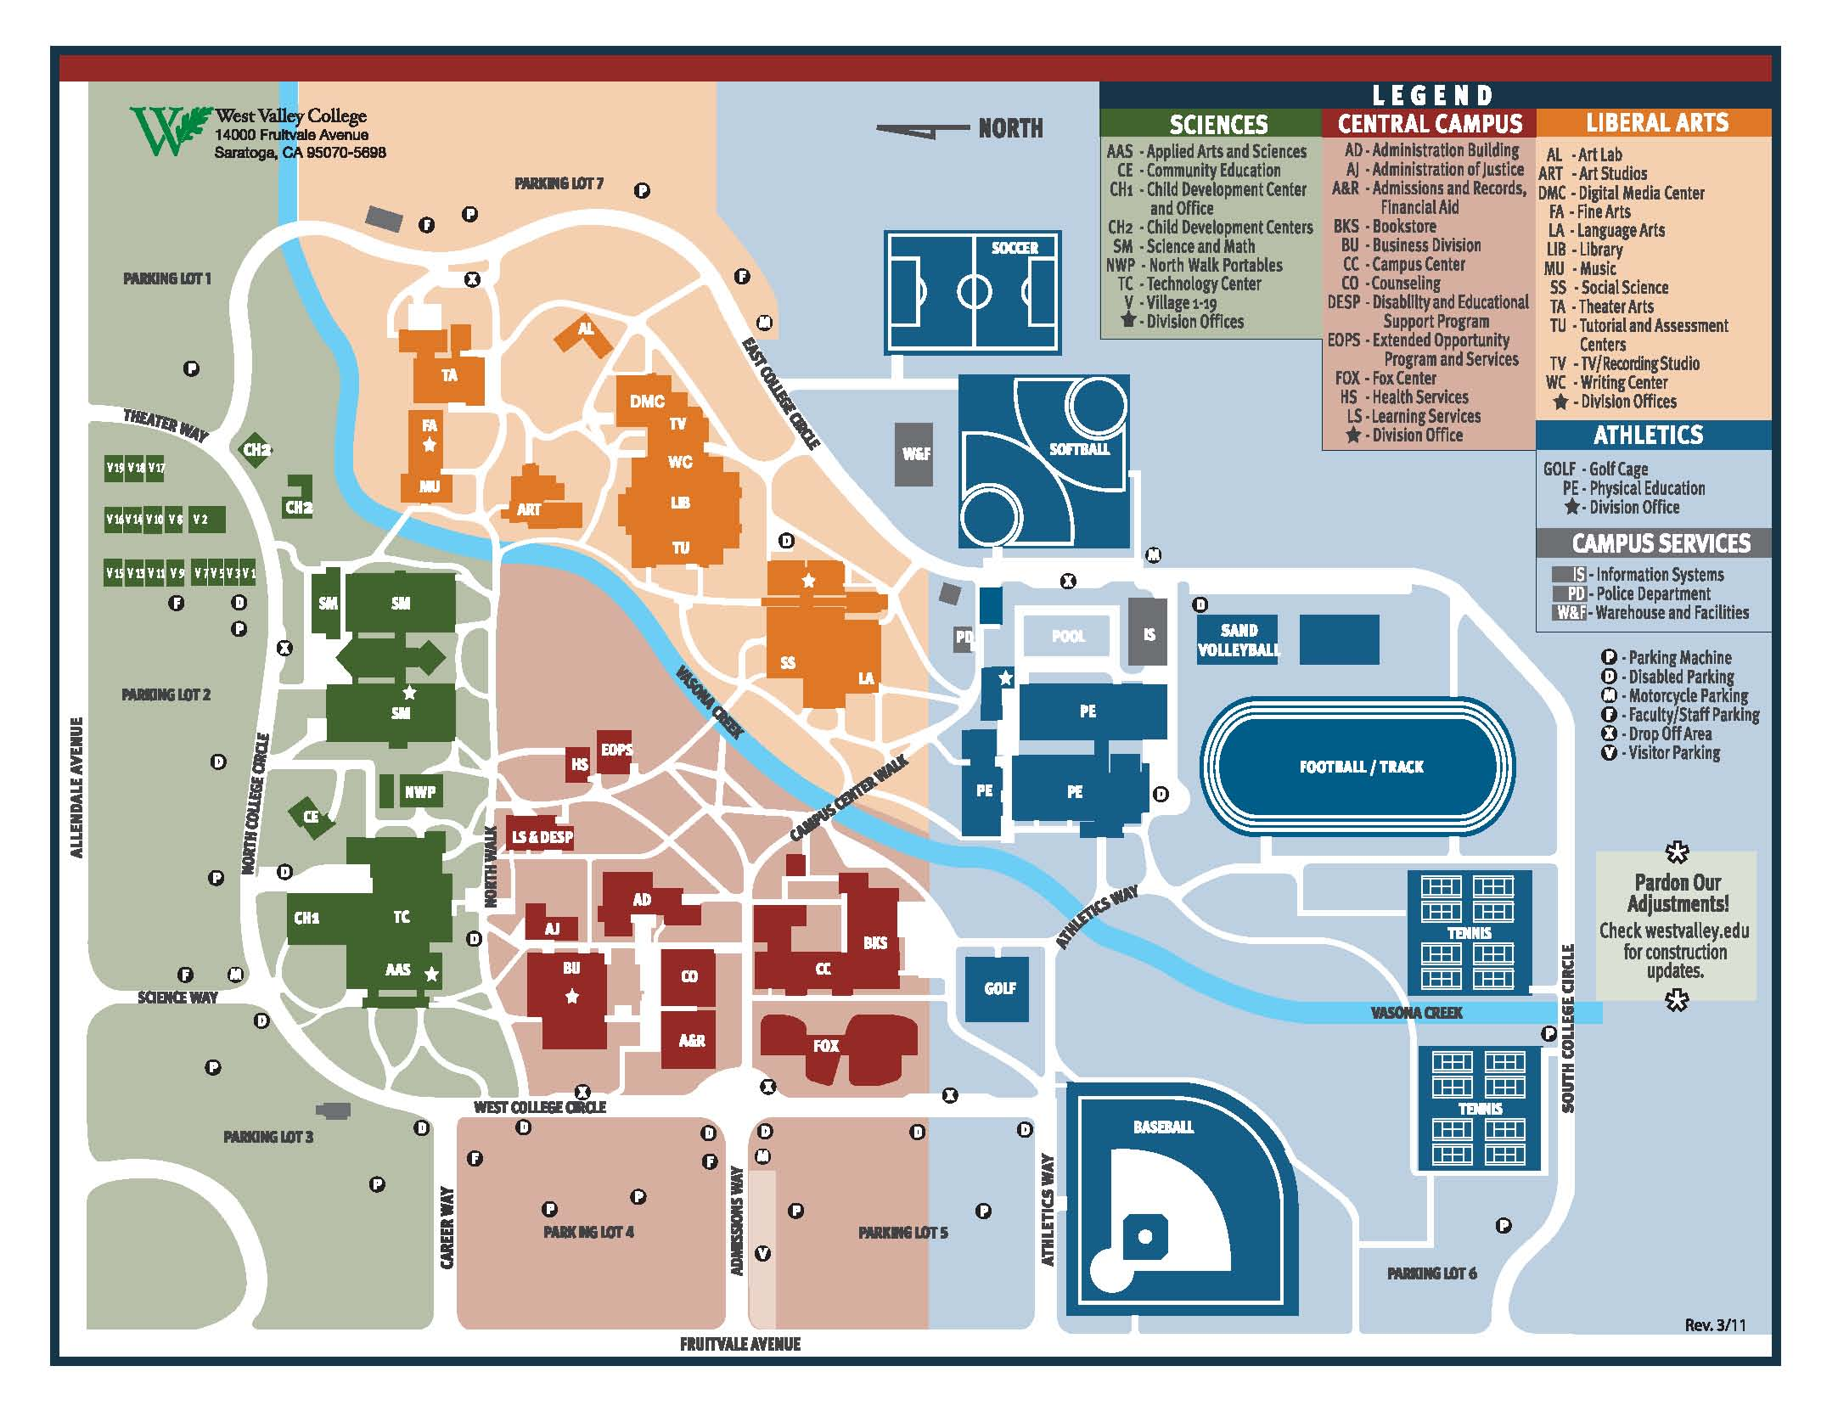
EXHIBIT B
Mission College:

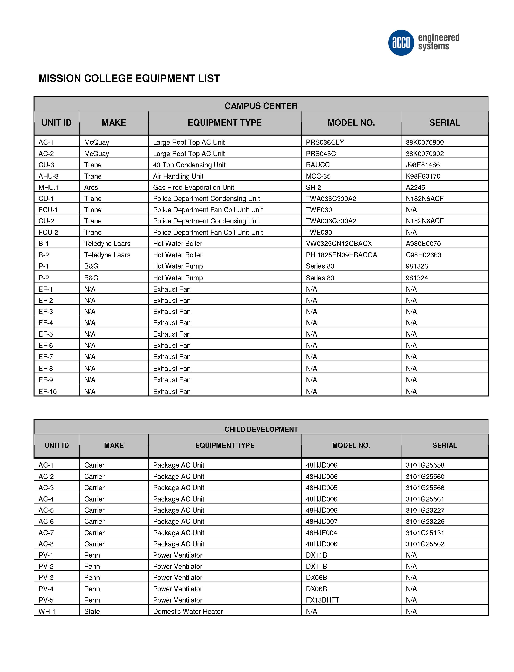

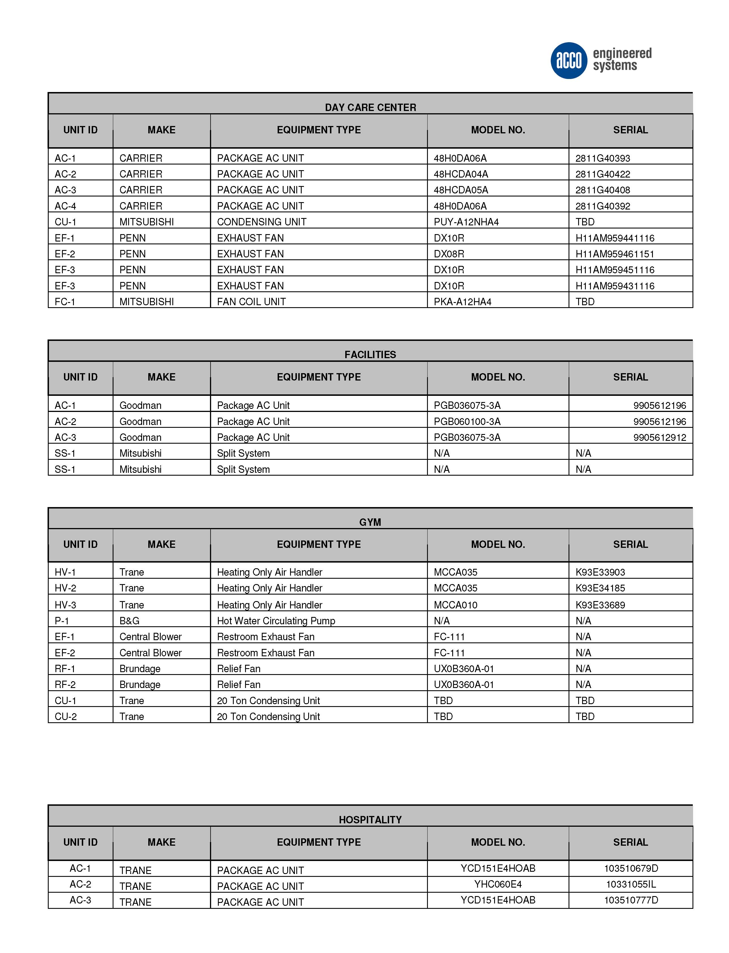

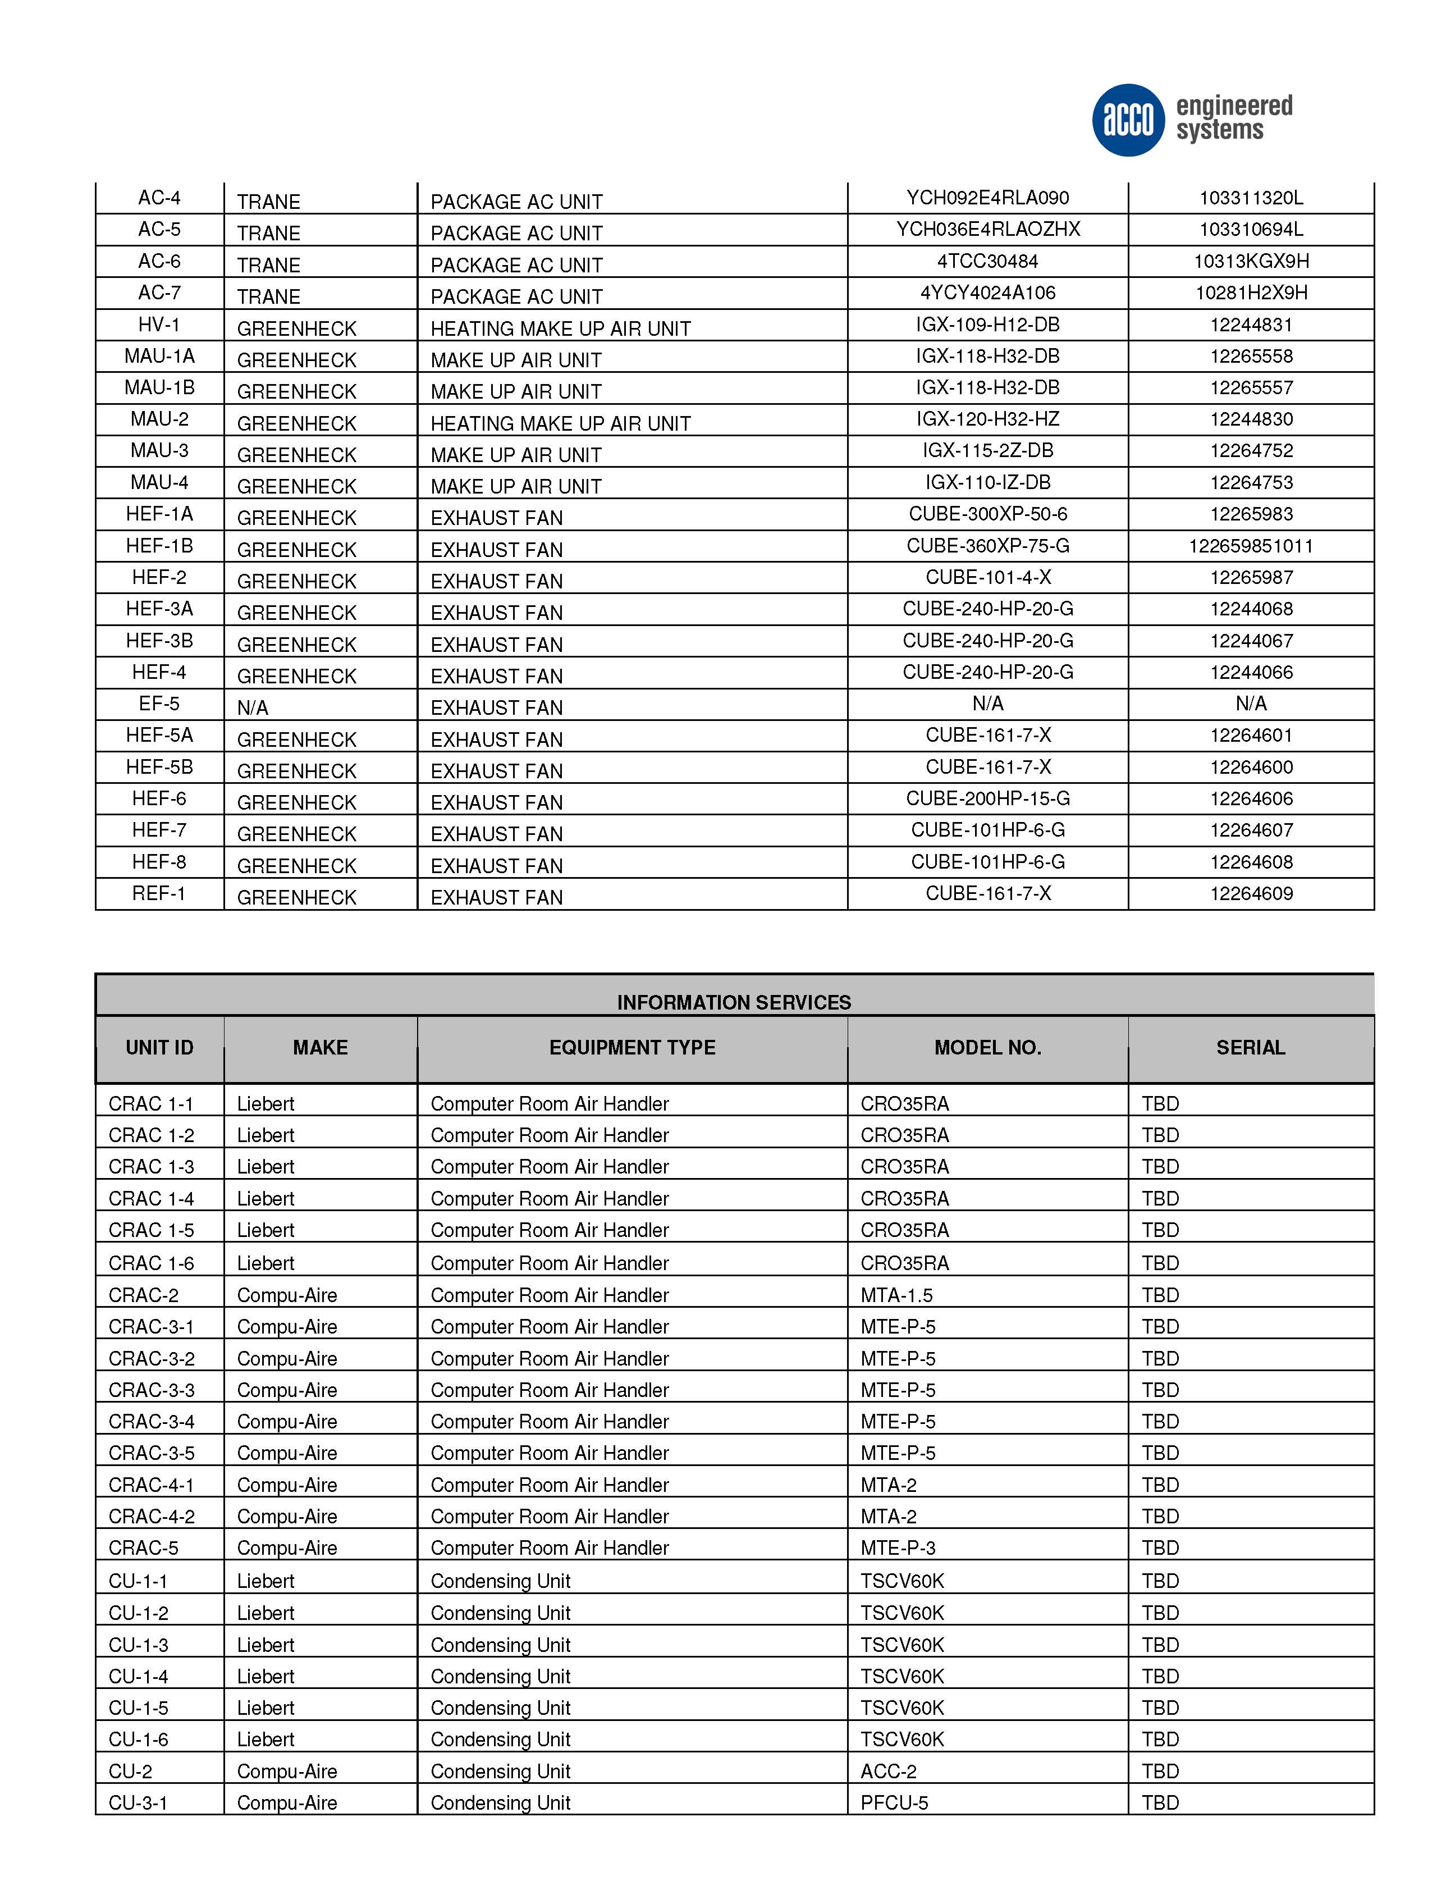

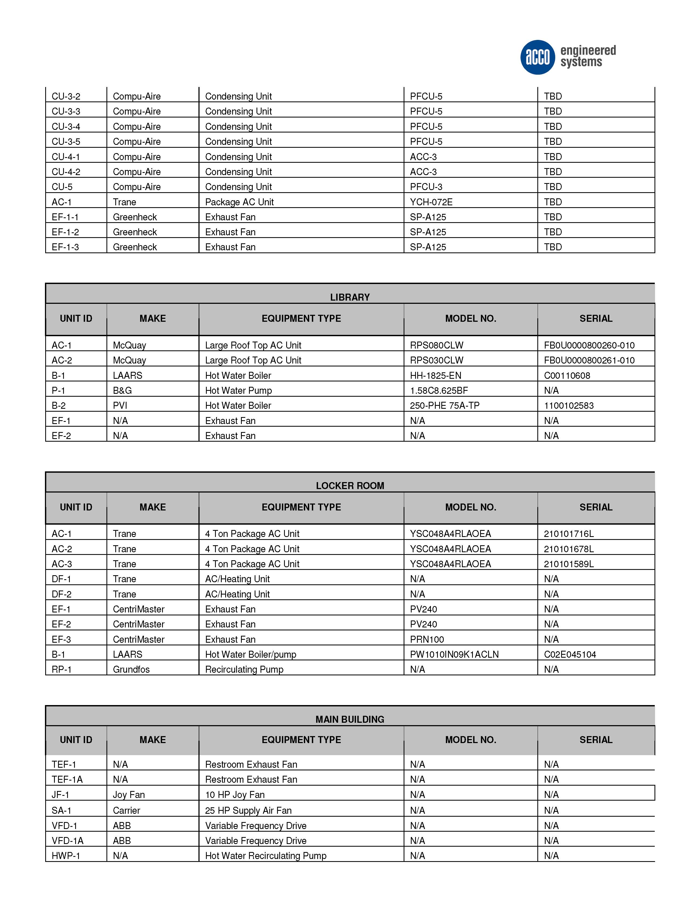

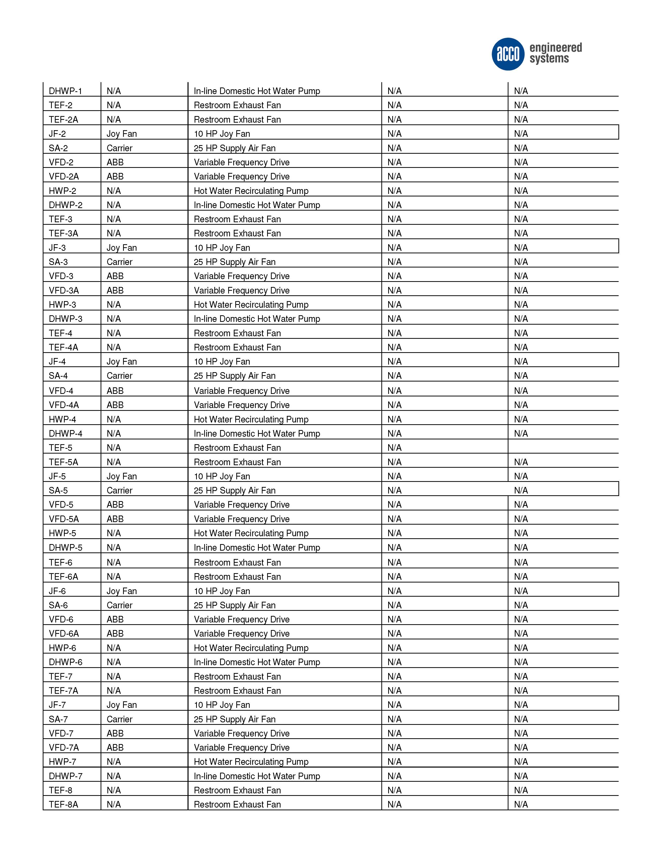

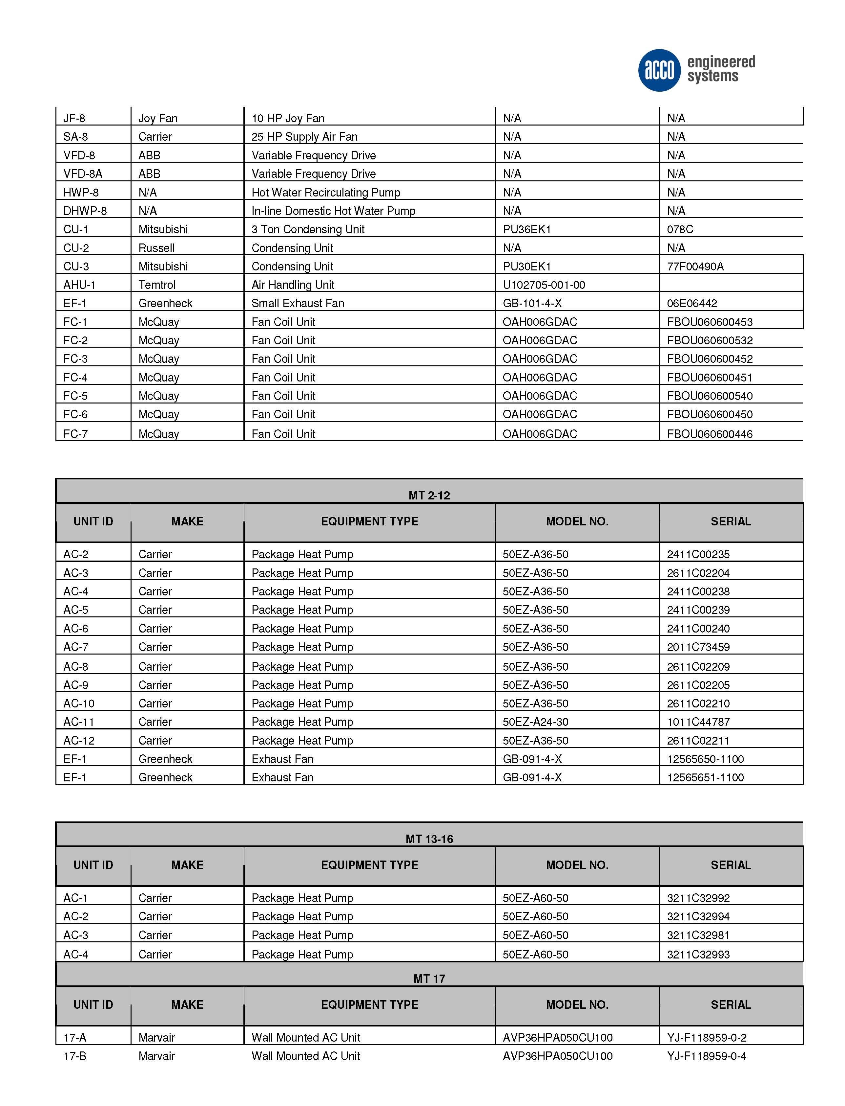

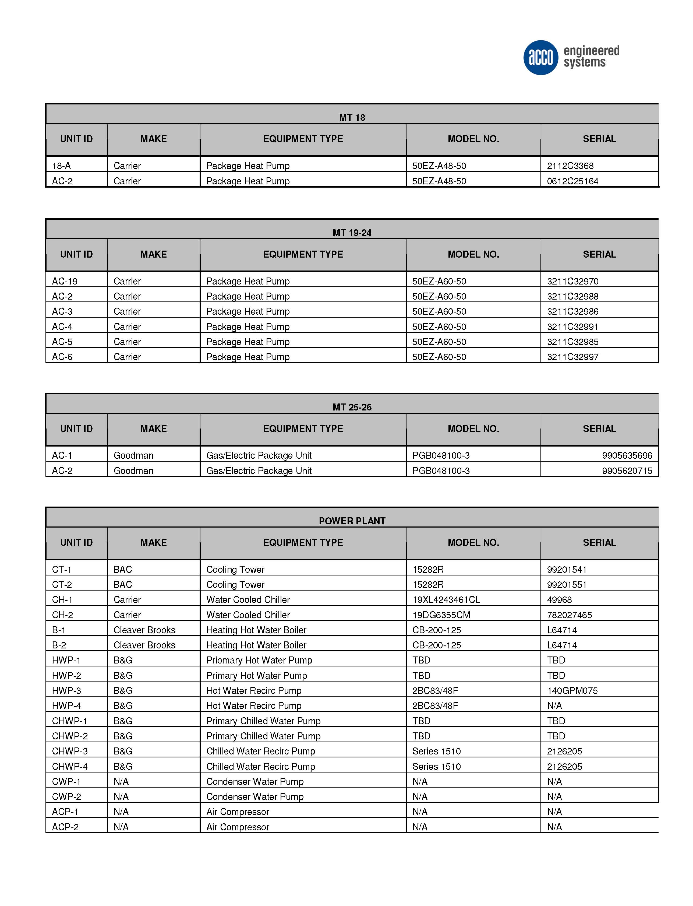

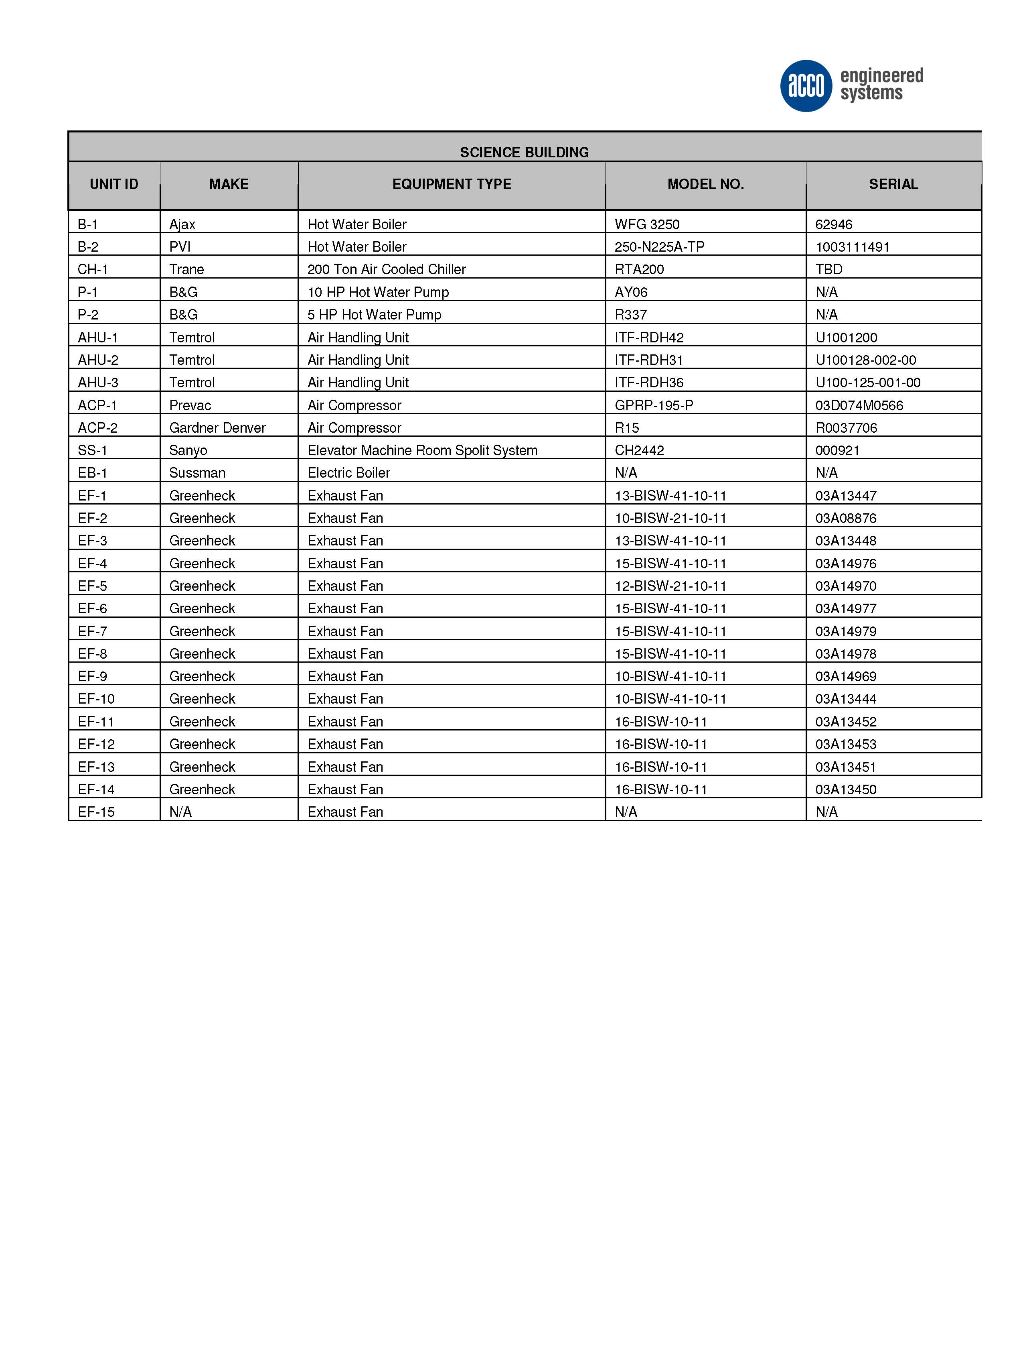
Mission College Map
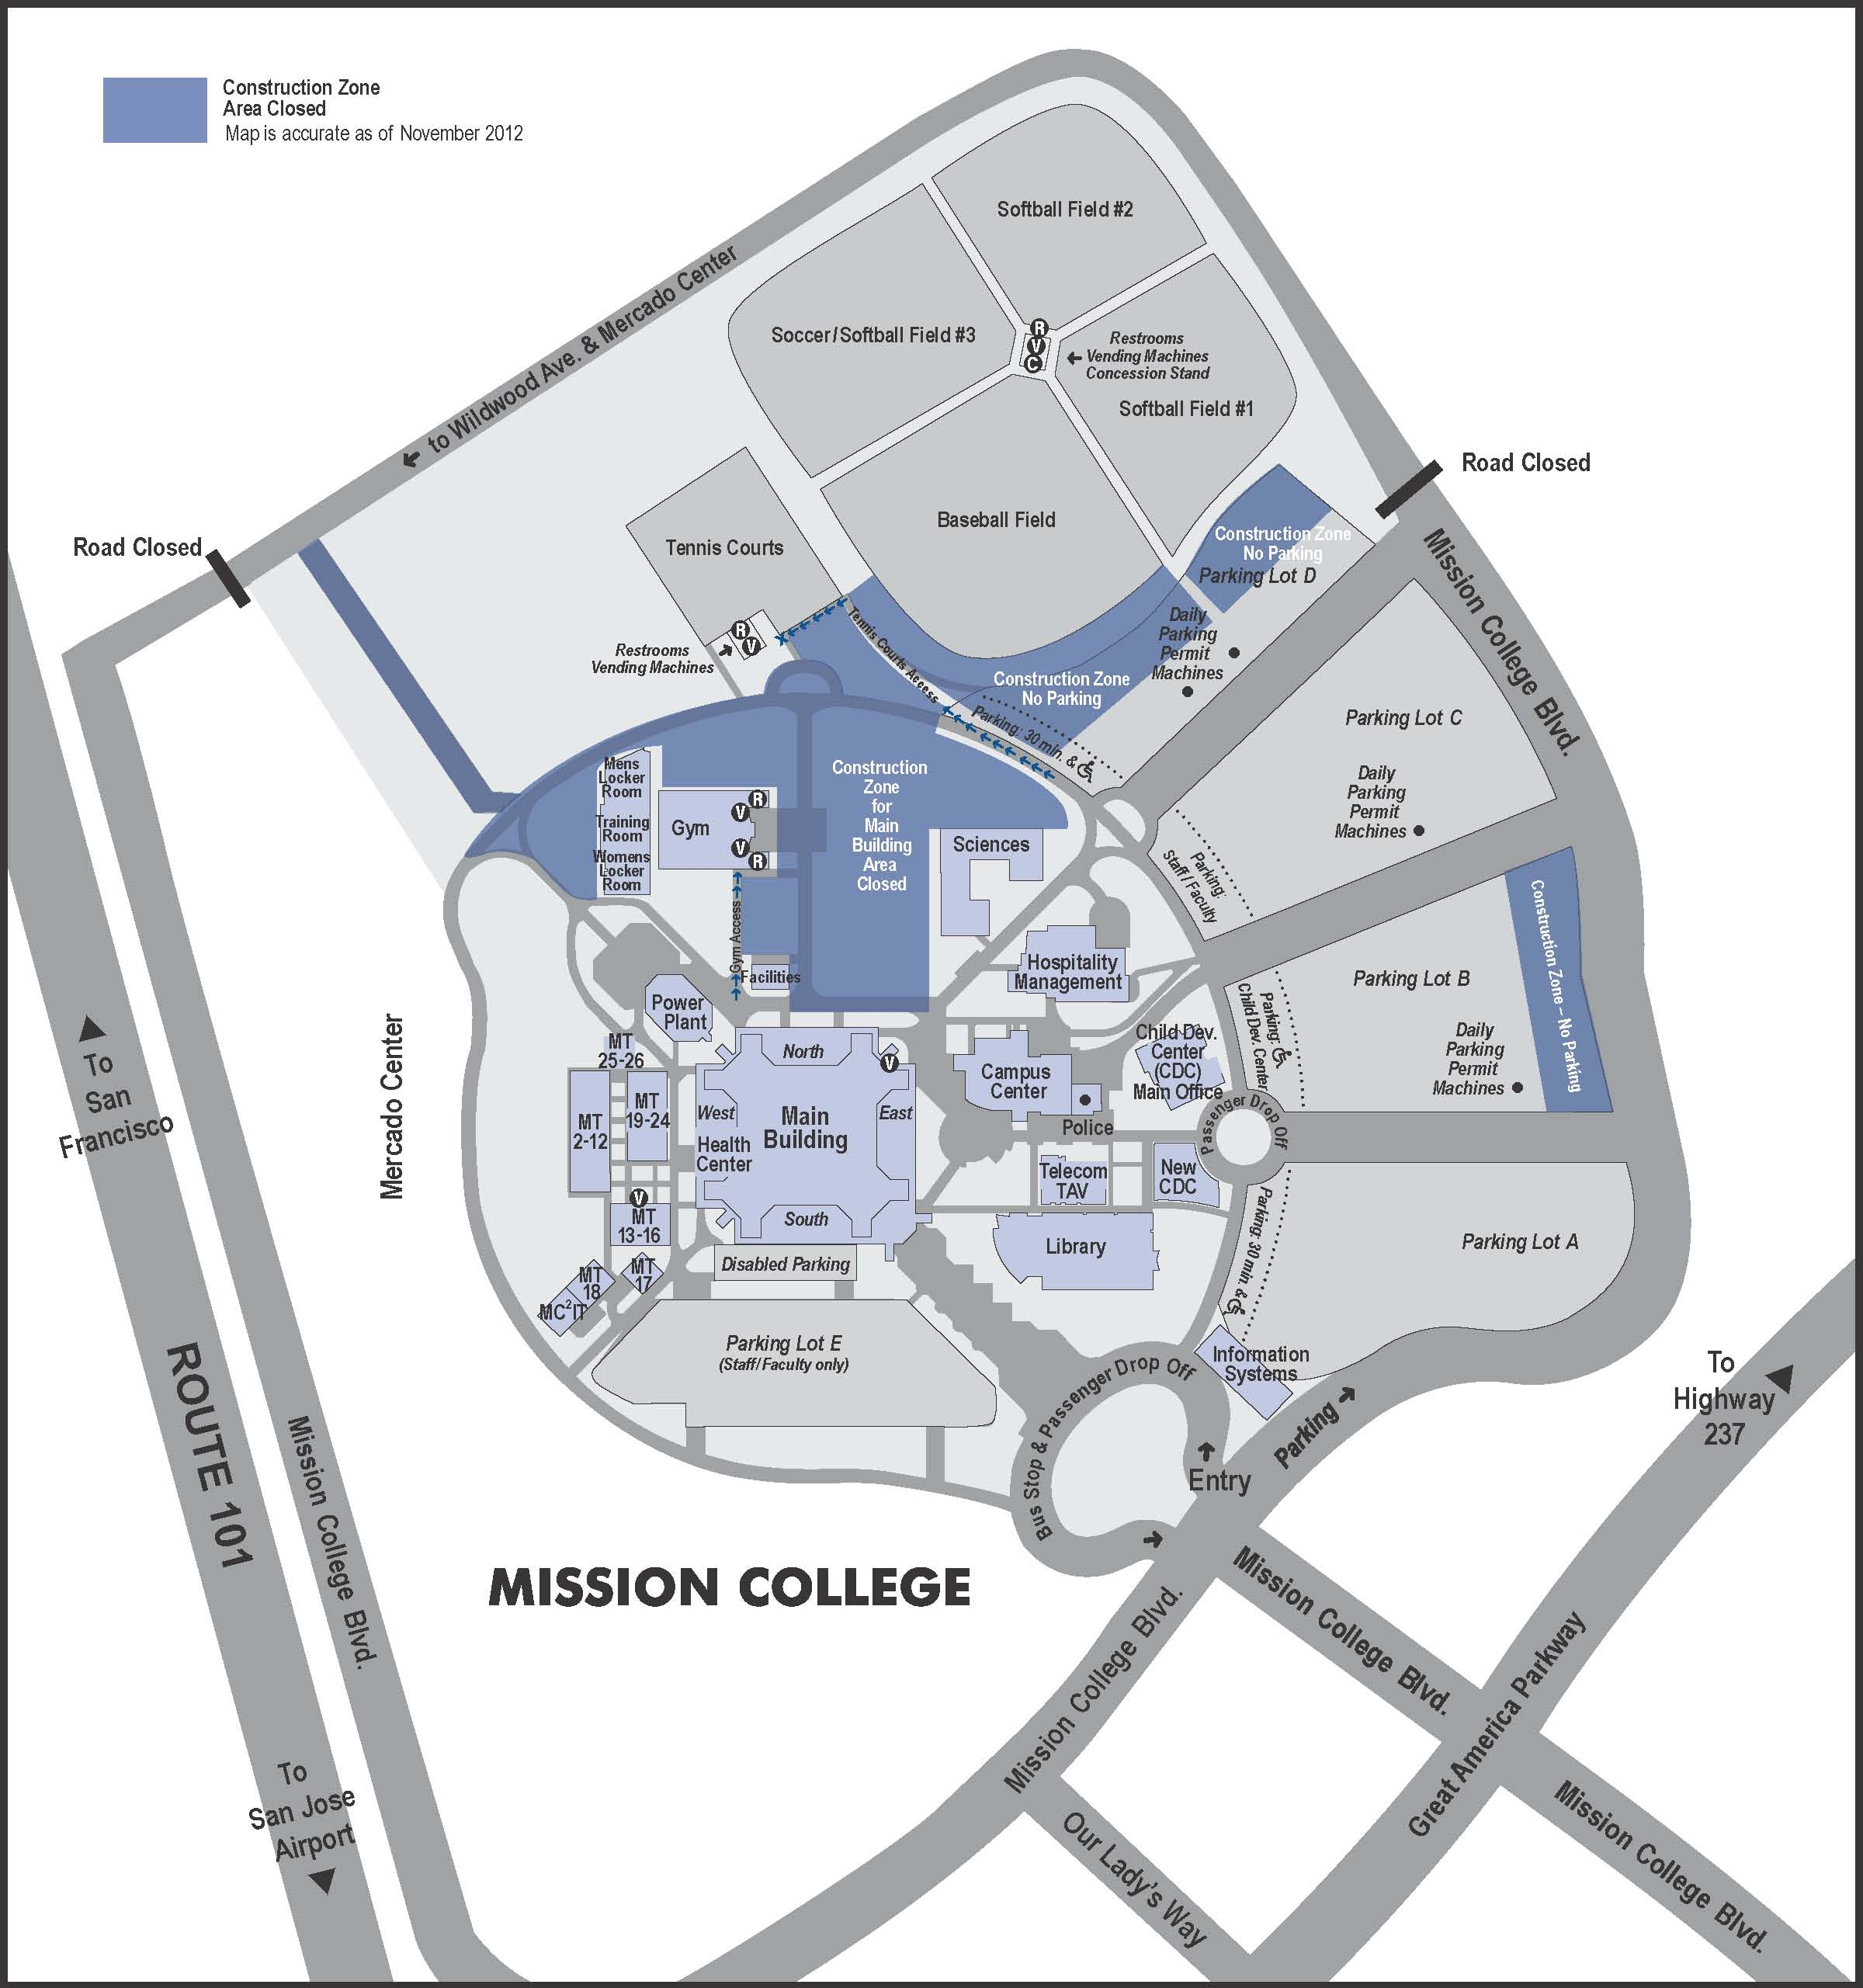
EXHIBIT C
COMPREHENSIVE SERVICE PLAN

Exhibit D

CONTRACTOR’S HAZARDOUS MATERIALS/ REFRIGERANT POLICY AGREEMENT

Hazardous Materials Policy Agreement:
The contractor agrees to use/provide only environmentally safe products while doing business with West Valley-Mission Community College District, in fulfillment of this contract; to describe in detail any products it shall use or provide, including necessary specifications indicating that the products meet with all requirements of law; to dispose of any material considered to be “hazardous” under any federal, state, or local statute, regulation, rule or ordinance in a lawful and environmentally safe manner; and to indemnify and hold harmless West Valley-Mission Community College District from any loss, damages or liabilities incurred as a result of use by or on behalf of __________________________________ of such products.
(Company Name)

The contractor shall provide to the facility owner or manager and post in a conspicuous location all applicable Material Safety Data Sheets.

Refrigerant Policy Agreement:

I, _______________________________, do hereby acknowledge that all of our service technicians have received training on venting, recovery, recycling, and replacement of chlorofluorocarbons (CFCs), hydrochlorofluorocarbons (HCFCs), and other refrigerants used in air conditioning and refrigerant systems, units, and small appliances, and have taken and passed an EPA-approved test appropriate for the equipment that they service and/or dispose of.

I agree that all of our service technicians will follow procedures for servicing, repairing, and disposing of any and all refrigerant-containing devices, units, and systems as outlined by company policy and federal, state, and local laws and regulations now in effect or hereinafter enacted which pertain to the Federal Clean Air Act of 1990.

I am aware of the significant harm to the earth’s atmosphere caused by venting refrigerants into the air. We agree not to willfully vent refrigerants into the air under any circumstances.

I understand that our organization will be held responsible and liable if I or any of our service technicians willfully violate the Federal Clean Air Act of 1990 regarding venting of refrigerants and that we are liable for any and all fines associated with violations (currently up to $25,000 per occurrence). Any unintentional venting will be documented in accordance with company policy.

I understand that if we willfully violate the Clean Air Act of 1990, we will fully protect, indemnify, hold harmless, and defend West Valley-Mission Community College District from and against any and all liability regarding the handling, venting, and/or disposal of any and all refrigerants.

We also agree to provide a copy of the Federal Certification numbers for all our service technicians. Should any certifications be revoked, we will notify West Valley-Mission Community College District immediately.

Signed _____________________________________________________

Printed Name _______________________________________________

Title ______________________________________________________

Company Name _____________________________________________

Date _______________________________________________________

CONTRACTOR’S HAZARDOUS MATERIALS/ REFRIGERANT POLICY AGREEMENT (Con’t)

Use space below and additional sheets, if necessary, to complete technician information.

Technician Name Certification No.

_____________________________________________________________________________________________

_____________________________________________________________________________________________

_____________________________________________________________________________________________

_____________________________________________________________________________________________

_____________________________________________________________________________________________

_____________________________________________________________________________________________

_____________________________________________________________________________________________

_____________________________________________________________________________________________

_____________________________________________________________________________________________

_____________________________________________________________________________________________

_____________________________________________________________________________________________

_____________________________________________________________________________________________

_____________________________________________________________________________________________

_____________________________________________________________________________________________

_____________________________________________________________________________________________

_____________________________________________________________________________________________

_____________________________________________________________________________________________

_____________________________________________________________________________________________

_____________________________________________________________________________________________

_____________________________________________________________________________________________

_____________________________________________________________________________________________

_____________________________________________________________________________________________

_____________________________________________________________________________________________

_____________________________________________________________________________________________

Exhibit E

FEE SCHEDULE

Service Category | Journeyman Rate | Multiplier | Final Proposed Journeyman Rate
Standard Service | _____________________ Dollars ($_______) |  | _____________________ Dollars ($_______)
Standard After Hours Service | _____________________ Dollars ($_______) |  | _____________________ Dollars ($_______)
Expedited Standard Service | _____________________ Dollars ($_______) |  | _____________________ Dollars ($_______)
Expedited After Hours Service | _____________________ Dollars ($_______) |  | _____________________ Dollars ($_______)
Emergency Standard Service | _____________________ Dollars ($_______) |  | _____________________ Dollars ($_______)
Emergency After Hours Service | _____________________ Dollars ($_______) |  | _____________________ Dollars ($_______)
Service Category | Helper Rate | Multiplier | Final Proposed  Helper Rate
Standard Service | _____________________ Dollars ($_______) |  | _____________________ Dollars ($_______)
Standard After Hours Service | _____________________ Dollars ($_______) |  | _____________________ Dollars ($_______)
Expedited Standard Service | _____________________ Dollars ($_______) |  | _____________________ Dollars ($_______)
Expedited After Hours Service | _____________________ Dollars ($_______) |  | _____________________ Dollars ($_______)
Emergency Standard Service | _____________________ Dollars ($_______) |  | _____________________ Dollars ($_______)
Emergency After Hours Service | _____________________ Dollars ($_______) |  | _____________________ Dollars ($_______)
Percentage mark-up on direct actual costs of materials |  |  | _______ percent (___%)

Material Pricing Schedule:

Refrigerant Oil disposal – Hazardous Material $_______ / Gal.
OXE/Torch/Welding: $_______/_______
Clean Air compliance – Vacuum pump: $_______ Each use
Clean Air compliance – Recovery Unit:
0-25 Pounds: $_______
26-110 Pounds: $_______
101-250 Pounds: $_______
Over 251 Pounds: $_______
ATTACHMENT 2

QUALIFICATIONS STATEMENT

- Contact Information
  - Respondent Name. ___________________________________________
  - Form of Entity. Check appropriate box.
- Corporation
_________________________________________________
(State of Incorporation & Corporate Registration No.)
- Partnership (General Partnership, Limited Partnership)
- Limited Liability Company
- Limited Liability Partnership
- Joint Venture
_________________________________________________
(Identify each member of Joint Venture and form of entity)
- Sole Proprietorship
  - Contact Person.

Name
Address
Phone/Fax
email

  - Respondent California Contractors License.

Classification(s)
Expiration Date
RMO/RME
Contractors’ License Bond Surety & Bond No.

- Essential Minimum Qualifications. Any response of a Respondent indicating “not qualified” to the following qualifications criteria will result in rejection of the Respondent’s RFP Response for failure to meet minimum qualifications criteria.

  - Respondent possesses a valid/good standing California Contractors’ License in the C-20, Warm-Air Heating, Ventilating and Air Conditioning
- Yes
- No (not qualified)

  - Respondent has a minimum of five (5) years’ experience servicing HVAC Maintenance Agreements for Commercial facilities and/or Education facilities of over 500,000 square feet.
- Yes (not qualified)
- No

  - Respondent’s California Contractors’ License has been suspended or revoked within the past five (5) years.
- Yes (not qualified)
- No

  - Respondent has obtained a current Commercial General Liability policy of insurance with coverage limits of at least One Million Dollars ($1,000,000) per occurrence and Four Million Dollars ($2,000,000) in the aggregate.
- Yes
- No (not qualified)

  - Respondent has obtained a current Workers Compensation policy of insurance with coverage limits in accordance with applicable law.
- Yes
- No (not qualified)

  - Respondent’s current Workers Compensation insurance EMR is 1.25 or less and the Respondent’s average EMR for the past five (5) years is 1.25 or less
- Yes
- No (not qualified)

  - Respondent is ineligible for award of public works contracts or to perform work as a Subcontractor on a public works Project pursuant to Labor Code §1777.1 or 1777.7.
- Yes (not qualified)
- No

  - Within the past five (5) years, one or more public or private construction project(s) of the Respondent has been completed by a surety on behalf of the Respondent.
- Yes (not qualified)
- No

  - A surety has refused to issue a surety bond on behalf of the Respondent for any private or public project.
- Yes (not qualified)
- No

  - Has any public agency, within the past ten (10) years conducted proceedings that resulted in a finding that the Respondent or any predecessor to the Respondent is not a “responsible” bidder for a public works project or a public works contract?
- Yes (not qualified)
- No

  - Has any public agency, within the past ten (10) years conducted proceedings that resulted in a finding that the Respondent or any predecessor to, or officer or director of, Respondent is not a “responsible” bidder for a public works project or a public works contract?
- Yes (not qualified)
- No

  - At any time during the last five (5) years, has Respondent or any predecessor, or officer or director of, Respondent been convicted of a crime involving any federal, state, or local law related to a public works project or public works contract?
- Yes (not qualified)
- No

  - At any time during the last five (5) years, has the Respondent or any predecessor to, or officer or director of, Respondent been convicted of a federal or state crime involving fraud, theft, or any other act of dishonesty?
- Yes (not qualified)
- No

  - Within the past five (5) years, one or more contract(s) for construction of any portion of a public works project or public works contract that the Respondent was a party to have been terminated for default of the Respondent.
- Yes (not qualified)
- No

- Background.
  - Contractor Experience.
    - Years In Business as an HVAC Maintenance Contractor. ____________
    - HVAC Maintenance/Repair Experience. On a separate attachment, provide details of prior experience of the Respondent in providing HVAC maintenance and repair services to public agencies and/or commercial facilities of over 500,000 square feet within the past five (5) years. The statement of experience describing prior experience must include at least: (i) description of scope of maintenance and repair services; (ii) what percentage of your business is HVAC maintenance service; and (iii) HVAC owner and owner’s representative contact information.
    - Contractor References. On a separate attachment, provide the name, address, telephone number, fax number and e-mail of references from a one-year HVAC Maintenance and Repair customer, a three-year HVAC Maintenance and Repair customer and two HVAC Maintenance and Repair customers of five or more years.
    - Personnel
      - Qualifications. On a separate attachment, identify what qualifications and training your service technicians are required to have.
      - Turnover Rate. What is your employee turnover rate? ___________________
___________________________________________________________________
___________________________________________________________________

      - Personnel and Personnel Certifications. On a separate attachment, identify the personnel proposed for maintenance and/or repair services and for each such person, describe the number of years’ experience they have, describe the level of their skill as a service technician (journeyman rating or equivalent required), indicate whether such person holds a CFC certification, and identify any and all additional current certifications, certifications of completion of factory/manufacturer training programs and similar authorizations to maintain or repair HVAC equipment, systems and components.

      - General Questions:

No. | Question | Yes | No
1 | Do you have a Policy/Procedures Manual defining each O&M task, such as checking refrigeration pressures and describing the methods used for accomplishing the task? If yes, please attach a copy of the face page and Table of Contents.
2 | Do you have a database of preventative maintenance tasks recommended either by manufacturer or other reliable source?
3 | Will Contractor commit the same two or three service technicians continuously to the maintenance of the District’s campus buildings?
4 | Will the Contractor have capable service technicians available 24 hours per day, 365 days per year?
5 | Is the Contractor willing to provide resumes for the primary technicians assigned to the buildings?
6 | Do you have service technicians that are factory trained on the District’s building’s brands of equipment and control system?
7 | Do your service technicians have access to and the ability to use state-of-the-art tools such as portable dataloggers for measuring variables and troubleshooting operational problems?
8 | Are your service technicians required to wear clean company uniforms with name tags?
9 | Are your test instruments calibrated at least annually, and are your calibration methods in accordance with those of the Bureau of National Standards?
10 | What is your maximum response time for emergencies? | ___ hours
11 | How many trucks to you have?
12 | Are you a participating HVAC service contractor in PG&E’s Commercial HVAC Quality Maintenance Program?
13 | Have you utilized the new HVAC industry standard, The American Society of Heating, Refrigeration and Air Conditioning Engineers (ASHRAE)/Air Conditioning Contractors for American (ACCA) Standard 180, which supports increased HVAC performance with enhanced planned maintenance?
14 | Have you assisted other Commercial or Educational Facilities in applying for and obtaining PG&E’s Commercial HVAC Quality Maintenance Program incentives?

  - Claims and Disputes.
    - Pending Claims and Disputes. The Respondent is presently engaged in a claim, dispute or other disagreement relating to or arising out of a construction project (excluding claims arising out of job-site accidents) in which the Respondent is seeking additional compensation or additional time or in which compensation is sought from the Respondent.
- Yes
- No
If “Yes” on a separate attachment, provide details of each such pending claim, dispute or other disagreement.

    - Prior Claims and Disputes. The Respondent has, within the past seven (7) years been engaged in a claim, dispute or disagreement relating to or arising out of a construction project or an assignment for HVAC maintenance or repairs (excluding claims arising out of job-site accidents) in which the Respondent sought additional compensation or additional time or in which compensation was sought from the Respondent.
- Yes
- No
If “Yes” on a separate attachment, provide details of such pending claim, dispute or other disagreement.

    - Judgments. Are there any judgments, orders, decrees or arbitration awards pending, outstanding against the Respondent or any of the officers or equity owners of Respondent which arise out of or are related in any manner to a construction project?
- Yes
- No

If “Yes” on a separate attachment, provide details of such pending claim, dispute or other disagreement.

The undersigned is duly authorized to execute this Qualifications Statement under penalty of perjury on behalf of the above-identified Respondent. The undersigned warrants and represents that he/she has personal knowledge of each of the responses to this Qualifications Statement and/or that he/she has conducted all necessary and appropriate inquiries to determine the truth, completeness and accuracy of responses to this Qualifications Statement. The undersigned declares and certifies that the responses to this Qualifications Statement are complete and accurate; there are no omissions of material fact or information that would render any response to be false or misleading and there are no misstatements of fact in any of the responses. The above-identified Respondent acknowledges and agrees that if the District determines that any response herein is false or misleading or contains misstatements of fact, the Response shall be deemed non-responsive and the Respondent will not further participate in the RFP process.

Executed this___ day of __________________ 20__ at_____________________________
(City and State)

I declare under penalty of perjury under California law that the foregoing is true and correct.

________________________________________
(Signature)

________________________________________
(Typed or written name)

ATTACHMENT 3

GENERIC SCOPE OF WORK

The scope of work represents a generic scope of work that applies to the majority of the manufacturers’ recommendations for their respective equipment types. The actual scope may vary based on the O&M of the specific manufacturer.

Hot Water Boiler Annuals:

Hot Water Boiler Annual Service
- Drain boiler as required to perform tests and inspections
- Perform slow drain test of low water cutoff
- Inspect refractory and firebrick for defects
- Clean expansion tank sight glass
- Verify accuracy of pressure gauges
- Try lever test safety relief valve
- Analysis of flue gases with electronic analyzer
- Inspect wire insulation for signs of overheating, burns, etc.
- Clean burners and orifices
- Vacuum out combustion chamber
- Replace pilot assembly
- Test and calibrate operating and safety controls

Annual Cooling Tower Drain & Flush:

Cooling Tower Drain & Flush
- Shut down tower and chemical feed systems
- Drain tower
- Clean sump
- Clean media
- Refill sump
- Restart tower and chemical feed systems

Water-Cooled Screw Chiller Annual:

Screw Chiller Annual Service
- Lubricate Equipment as needed
- Perform leak test
- Calibrate Operating controls
- Inspect contactors
- Tighten Electrical connections
- Check starter wiring
- Check gauges and indicator lights
- Check Motors Amps & Volts
- Calibrate Controls
- Obtain oil and Refrigerant samples and send to lab for analysis
- Replace Oil Filter
- Cooler EWT LWT TD °F
- Condenser EWT LWT TD °F
- Chiller Operation LOG
- Cooler: Refrigerant Pres # Temp °F
- Cooler: Water Pres IN # OUT #
- Cooler: Water Temp IN °F OUT °F
- Cond: Refrigerant Pres # Temp °F
- Cond: Water Pres IN # OUT #
- Cond: Water Temp IN °F OUT ° F
- Comp: Oil Pres (diff) # Temp ° F Level HI OK LO
- Comp: Motor RLA A Ampdraw A %Load %
- Mechanically brush condenser tubes

Air Compressor Annual:

Air Compressor Annual Services
- Drain compressor oil level.
- Replace oil.
- Check operation of automatic tank draining device and drain tank if necessary.
- Inspect high pressure safety valve(s), pressure reducing valves and gauges.
- Check motor operating conditions, and record voltage and amp draws.
- Lubricate motor bearings per manufacturer’s specifications.
- Test pneumatic electric controller for proper operation.
- Check setpoints, and adjust as required.
- Inspect motor starter and alternator for condition and proper operation.
- Inspect intake air filter and replace as required.
- Check air drier temperature(s) and pressure(s) as required
- Check bypass valve for leaks and operation

Quarterly Maintenance Scope of Work:

Below are some samples of the tasks to be performed during the quarterly maintenance.

Hot Water Boilers
- Monitor heating performance – compare to standard
- Check for proper pilot and burner combustion
- Check fire box for cracks
- Verify water pressure & temperature
- Check safety controls
- Check for water leaks
- Check for rust, corrosion

Exhaust And Supply Fans
- Inspect fan for cleanliness
- Check fan wheel or blades for free rotation
- Check/adjust belt tension and alignment
- Lubricate bearings
- Inspect ductwork for leaks
- Inspect pleated pre-filters

Cooling Tower
- Clean debris from unit
- Clean sump strainer
- Check & adjust sump water level as required
- Inspect heat transfer section for scale
- Inspect spray nozzles or distribution pans
- Check operation of make-up valve
- Check motor voltages & current
- Check/adjust V-belt condition and tension
- Inspect protective finish

Air Cooled Package Units
- Inspect/Adjust belts and sheaves (where applicable)
- Check discharge and suction temperatures, pressures
- Inspect piping for leaks
- Inspect coils for leaks and check refrigerant charge
- Check refrigerant charge
- Check operation of crankcase heater
- Lubricate fan bearings
- Check/clean condensate drip pans and drains
- Check expansion valves and bulb clamps
- Check operation of inlet guide vanes if applicable
- Check condition of fans, fan wheels, and coils
- Check economizer damper linkage, lubricate as needed
- Check economizer operation and minimum position setting
- Check exhaust fan(s) operation and inspect belts and sheaves
- Lubricate bearings/motors
- Inspect air cooled condenser coils surface for cleanliness
- Inspect indoor evaporator surface for cleanliness
- Check fan blades and condition
- Inspect pre-filters
- Check for cleanliness

Air Cooled Split Systems
Condensing Unit
- Visually check for leaks or pipe chafing
- Check oil level
- Check superheat and verify proper condensing temperature
- Check for proper refrigerant charge
- Check operation of crankcase heater
- Check for proper refrigerant operating pressures and temperatures
- Check for proper rotation of condenser fan
- Test for secureness of guards, doors and panels
- Check for cleanliness
Air Handler
- Visually inspect for air and water leaks
- Visually inspect for chafing or loose piping or wiring
- Verify cleanliness of fan, coils, and condensate system
- Check/adjust fan belt (where applicable)
- Visually inspect fans for dirt, debris, tightness
- Check panels, guards are tight and secure
- Inspect air filters

Water Pumps
- Lubricate pump bearings
- Check operating pressures
- Check alignment
- Check seals and packing
- Check expansion tanks
- Check motor starters and aux. Contacts
- Check flow switch
- Check for cleanliness
- Inspect expansion tank for leaks, condition, and operation

ATTACHMENT 4

PRICE PROPOSAL

A. West Valley College:

Building | Map Designation | Pricing | Pricing for Enhanced  Maintenance
Administration Building Bldg 1 | AD
Administration of Justice Bldg 2 | AJ
Admissions and Records Bldg 3 | A&R
Applied Arts and Sciences Bldg 10 | AAS
Art Lab Bldg 13D | AL
Art Studios Bldg 13E | ART
Business Division Bldg 4 | BU
Campus Center Bldg 6 | CC
Child Development Center | CH1 | See Applied Arts and Science
Child Development Center | CH2
Community Education (Gurlian) Bldg 12 | CE
Counseling Bldg 9 | CO
Disability & Educ. Support Prog. | DESP | See Learning Services
Extended Opp. Program & Serv. Bldg 7 | EOPS
Fine Arts & Music Bldg 13 | FA
Fox Center Bldg 58 | FOX
Health Services Bldg 14 | HS
Information Systems Bldg 57 | IS
Library Bldg 16 | LIB
Learning Services & Disability and Education Support Bldg 17 | LS
North Walk Portables | NW
Physical Education (Dance) Bldg 18B | PE
Physical Education (Faculty) Bldg 18A | PE
Physical Education (Gym) Bldg 18D | PE
Physical Education (Gym 2) Bldg 18C | PE
Physical Education (star) Bldg 18 | PE
Police Department Bldg 19 and 55 | PD
Pool Boiler House | N/A
Pool Shower Rooms | N/A
Science & Math (New) Bldg 56 | SM
Science & Math (Old) Bldg 20 | SM
Social Science (Language Arts) Bldg 15 | SS
Technology Center Bldg 10 | TC
Theater Arts Bldg 13B | TA
Village 1-19 | V
Warehouse and Facilities Bldg 21 | W&F
CAMPUS TOTALS |  | $

B. Mission College:

Building | Pricing | Pricing for Enhanced  Maintenance
Campus Center
Child Development
Day Care Center
Facilities
Gym
Hospitality
Information Systems
Library
Locker Room
Main Building
MT 2-12
MT 13-16
MT 17
MT 18
MT 19-24
MT 25-26
Power Plant
Science Building
CAMPUS TOTALS

C. Condenser Coil Cleaning:

In order to ensure that your air-cooled equipment is operating at peak energy efficiency, Respondent will perform a washing of the condenser coils with a biodegradable solution as required per manufacturer.

Respondent’s price for this service shall be as follows:

West Valley College: $ _______________________ Mission College: $ _____________________

D. Total Pricing:

The Grand Total for the Preventive Maintenance Service and Condenser Coil Cleaning shall be:

CAMPUS |  | PM Service including Quarterly Service | Annual Services | Condenser Coil Cleaning | TOTALS
West Valley College
Mission College
 | GRAND TOTAL:

E. Additional financial considerations:

Service Category | Journeyman Rate | Multiplier | Final Proposed  Journeyman Rate
Standard Service | _____________________ Dollars ($_______) |  | _____________________ Dollars ($_______)
Standard After Hours Service | _____________________ Dollars ($_______) |  | _____________________ Dollars ($_______)
Expedited Standard Service | _____________________ Dollars ($_______) |  | _____________________ Dollars ($_______)
Expedited After Hours Service | _____________________ Dollars ($_______) |  | _____________________ Dollars ($_______)
Emergency Standard Service | _____________________ Dollars ($_______) |  | _____________________ Dollars ($_______)
Emergency After Hours Service | _____________________ Dollars ($_______) |  | _____________________ Dollars ($_______)
Service Category | Helper Rate | Multiplier | Final Proposed  Helper Rate
Standard Service | _____________________ Dollars ($_______) |  | _____________________ Dollars ($_______)
Standard After Hours Service | _____________________ Dollars ($_______) |  | _____________________ Dollars ($_______)
Expedited Standard Service | _____________________ Dollars ($_______) |  | _____________________ Dollars ($_______)
Expedited After Hours Service | _____________________ Dollars ($_______) |  | _____________________ Dollars ($_______)
Emergency Standard Service | _____________________ Dollars ($_______) |  | _____________________ Dollars ($_______)
Emergency After Hours Service | _____________________ Dollars ($_______) |  | _____________________ Dollars ($_______)
Percentage Mark-Up on Direct Actual Costs of Materials |  |  | _______ percent (___%)

F. Material Pricing Schedule:

Refrigerant Oil disposal – Hazardous Material $_______ / Gal.
OXE/Torch/Welding: $_______/_______
Clean Air compliance – Vacuum pump: $_______ Each use
Clean Air compliance – Recovery Unit:
0-25 Pounds: $_______
26-110 Pounds: $_______
101-250 Pounds: $_______
Over 251 Pounds: $_______

